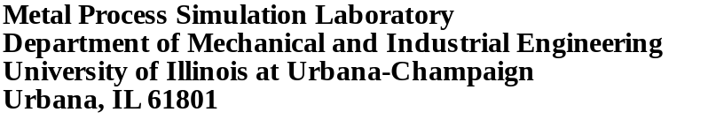

Ideal taper prediction for high speed billet casting. Part II

Chunsheng Li, Brian G. Thomas, and Claudio Ojeda

Continuous Casting Consortium

Report
2002

Submitted to

Accumold
AK Steel
Columbus Stainless
Hatch Associates/SMS

October 15, 2002

ideal taper prediction for high speed billet casting

Chunsheng Li, Brian G. Thomas, and Claudio Ojeda
University of Illinois Mechanical Engineering
1206 W. Green St., Urbana, IL 61801
bgthomas@uiuc.edu; 217-333-6919 or 217-244-4656

NEW simulation conditions

The modification introduced in this work is the new heat flux function. The new instantaneous heat flux function of distance down the mold (equation (1)) used in this work was obtained by differentiating equation (2) with total mold residence time.
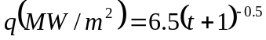 (1)
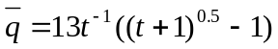 (2)

The instantaneous new high heat flux function and the former low heat flux function are compared in Fig. 1.
Initial simulations were performed for a 0.27%C steel (see phase transformation temperatures in Table 1) and working mold lengths of 500, 700, and 1000 mm (600, 800, and 1100 mm total length). Details of the 1D transient finite element mesh are given in Table 2.

EFFECT OF HEAT FLUX

With the higher heat flux function, (about 25% higher – Fig. 1), the shell surface temperature is lower (100 C lower at mold exit -figures Fig. 2 and Fig. 3). As a result, the shrinkage and taper are much greater, (by about 50%) as shown in figures Fig. 6 and Fig. 8, both figures for the cases with ferrostatic pressure.
Effect of Mold Distortion
The mold distorts away from the shell, especially at and just below the meniscus. This should be taken into account when designing the mold taper. Specifically, the local distortion of the mold away from the shell, relative to that at the meniscus, should be added to the wall position, in order to find the mold taper at ambient temperature. Elastic distortion of a billet mold is estimated with the following equation:
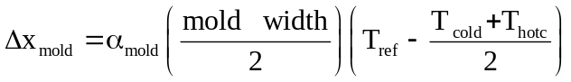 (5)
Where Δx_{mold} is the mold distortion (mm), α_{mold} is the thermal expansion coefficient of the copper (1.6x10⁻⁵), mold width is in mm, T_{ref} is average copper temperature at the meniscus, T_{cold} and T_{hot} are the cold and hot face temperatures at any given distance below the meniscus.
Effect of mold length
Tables 3 show that the shrinkage is governed by the heat flux profile. Shrinkage in this work is considered as %/mold unless otherwise specified. Longer molds need more taper (per mold), owing to the extra cooling from the extra dwell time, but need less taper (per meter) owing to decreasing heat flux further below the meniscus.
For a given set of conditions, the shrinkage profiles for different mold lengths all collapse onto a single curve. Results for any mold length are given simply by truncating the curve at the desired working mold length. This is due to the universal heat flux function assumed for all cases. This result demonstrates consistency of the computations. The remaining simulations are all performed on the same mold length.
Effect of casting speed
The effect of casting speed is shown in figures Fig. 2 to Fig. 9, using CON2D with the 1D-slice domain. The results at mold exit are summarized in Fig. 9 and tabulated in Table 3 with ferrostatic pressure. Naturally, higher casting speed produces less dwell time and consequently thinner shell, which has less shrinkage, so requires less taper. The decrease in required taper is not as much as might be expected, however, due to the higher average mold heat flux, which lowers the shell surface temperature (for a given time).
The shape of all curves is similar. As for all of the results, significantly more mold taper is required just below the meniscus than near mold exit. A mold wall shape such as a parabolic taper is therefore important.
Note that an increase in slope occurs near the beginning of each curve. This corresponds to the sharp drop in the heat flux at 1 second. This effect suggests that the shape of the heat flux curve has a great influence on the ideal taper.

EFFECT OF FERROSTATIC PRESSURE
The ferrostatic pressure pushes the solid steel shell against the mold. This effect is bigger in wider slabs as shown in Fig. 11, obtaining the smallest shrinkage for the 200 mm billet.

CONCLUSIONS
Computational models have been developed and applied to predict ideal taper during continuous casting of steel billets. The models quantify the ideal taper under a variety of conditions and the predictions include the following:
1. More taper is needed for the higher heat flux cases.
2. Mold distortion has a minor influence on ideal taper, so long as there is no permanent plastic deformation.
3. As casting speed increases, shrinkage decreases (for a given heat flux profile).
- Mold taper depends mainly on the heat flux profile, which in turn depends on the casting speed and interface conditions (powder, steel grade, etc.).
- Ferrostatic pressure pushes the steel shell against the mold. For bigger widths the ferrostatic pressure is bigger and therefore the shell shrinkage smaller.

Table 3: Material Transformation Temperatures
Steel Composition (wt%) | 0.27C, 1.52Mn, 0.34Si, 0.015S, 0.012P
Liquidus Temperature (ºC) | 1500.72
70% Solid Temperature (ºC) | 1477.02
90% Solid Temperature (ºC) | 1459.90
Solidus Temperature (ºC) | 1411.79
Austenite→α-Ferrite Starting Temperature (ºC) | 781.36
Eutectoid Temperature (ºC) | 711.22

Table 4: Simulation Conditions (standard conditions in bold)
Billet Section Size (mmmm) (for mold distortion) | 120120
Working Mold Length (mm) | 1000
Total Mold Length (mm) | 1100
Taper (%m) | 0.75 (on both face)
Time to turn on ferrostatic pressure (sec.) | 0.3
Mesh Size (mmmm) | 0.10.1
Time Step Size (sec.) | 0.001 - 0.5
Pouring Temperature (ºC) | 1540.0

Table 5: Casting speed study for high heat flux with ferrostatic pressure
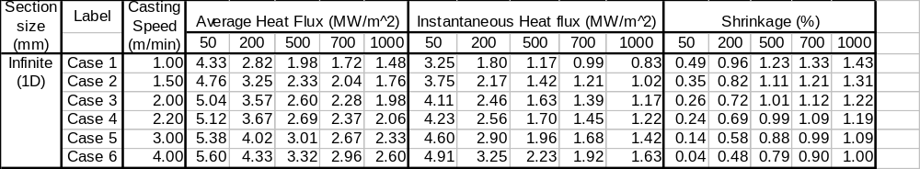

Table 4: Mold distortion for high heat flux
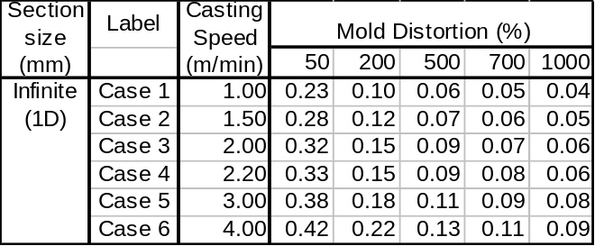

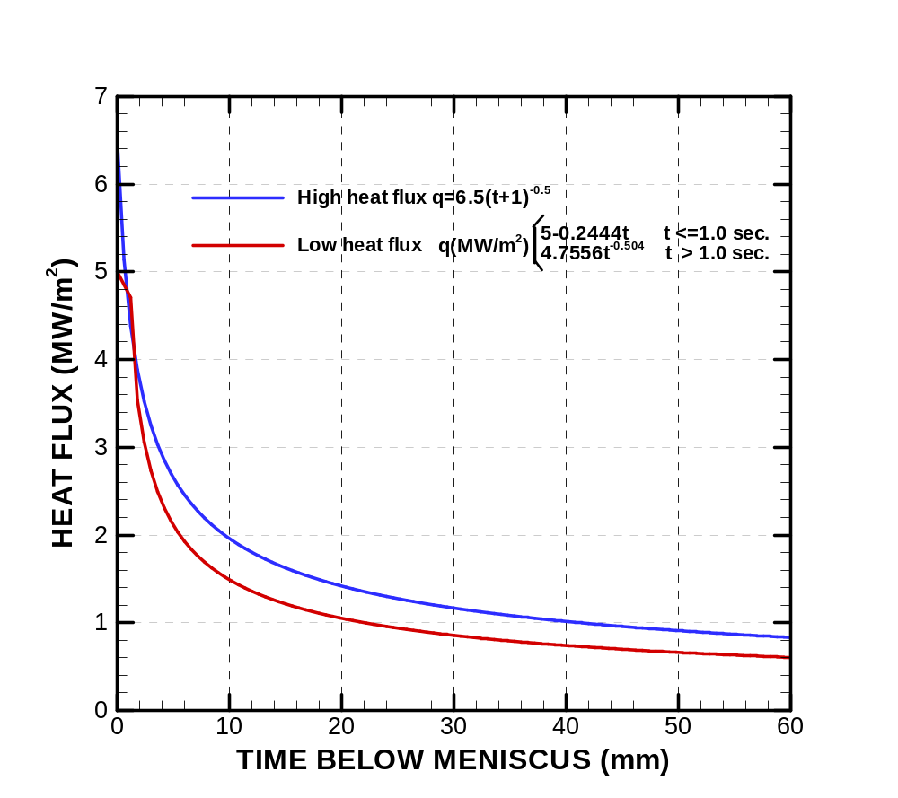
Fig. 1: Instantaneous Heat Flux Curves

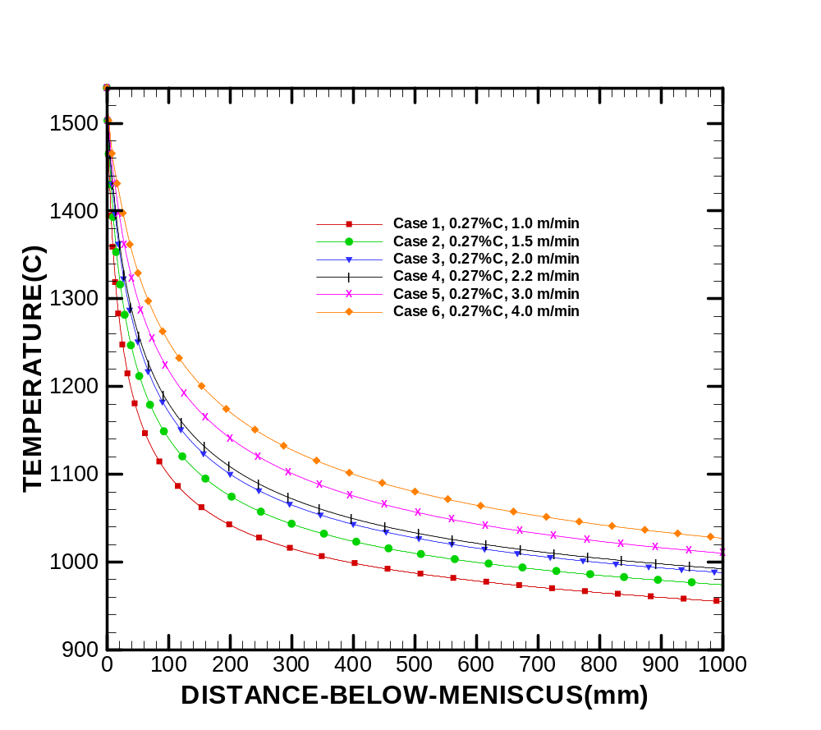
Fig. 2: Effect of casting speed on shell surface temperature for high heat flux with ferrostatic pressure
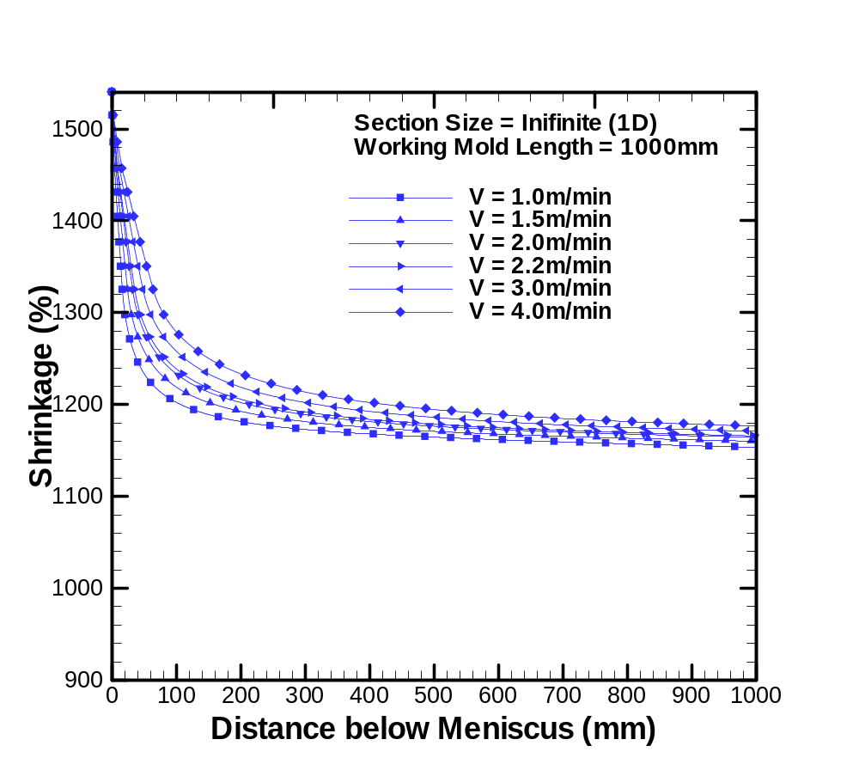
Fig. 3: Effect of casting speed on shell surface temperature for low heat flux with ferrostatic pressure

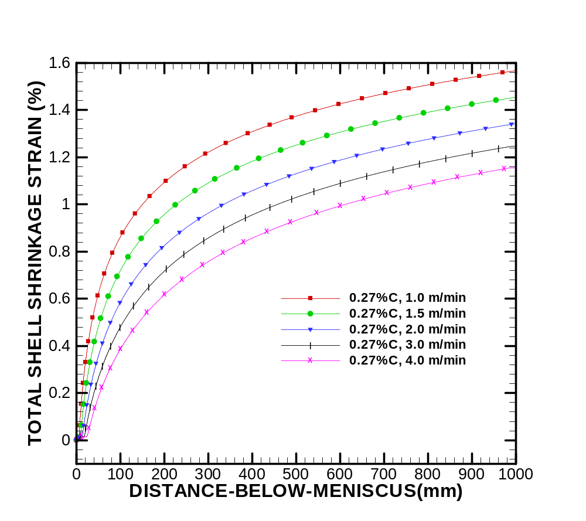
Fig. 4 Effect of casting speed on shell shrinkage for high heat flux without ferrostatic pressure
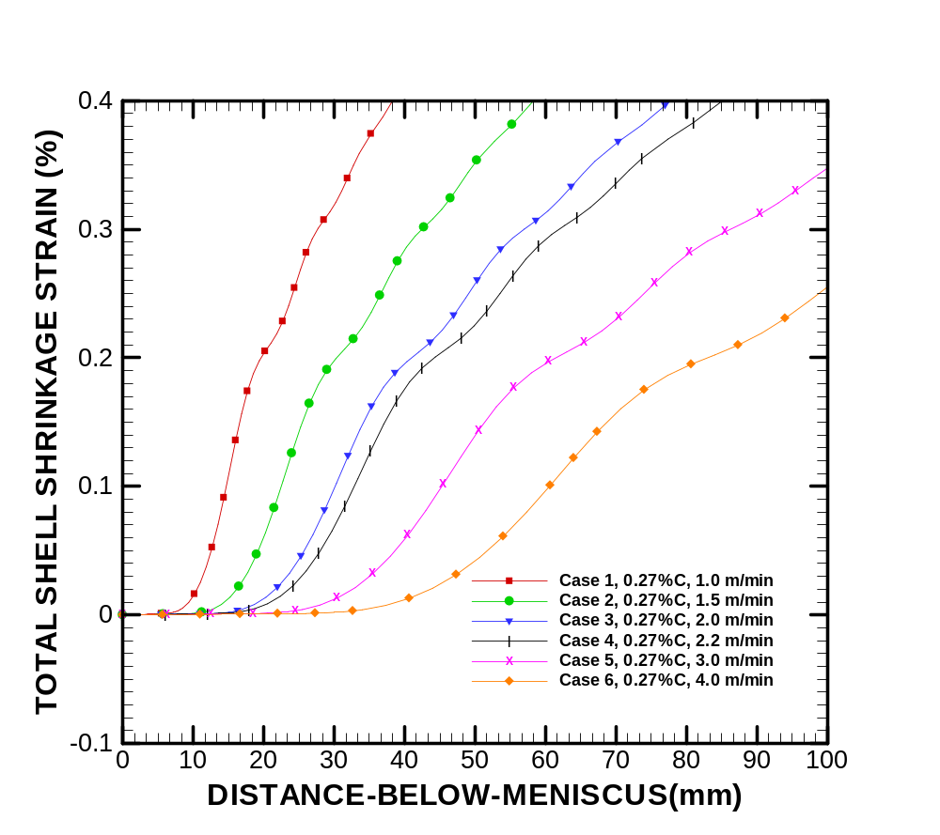
Fig. 5: Detail of the shell shrinkage near the meniscus for high Heat flux without ferrostatic pressure
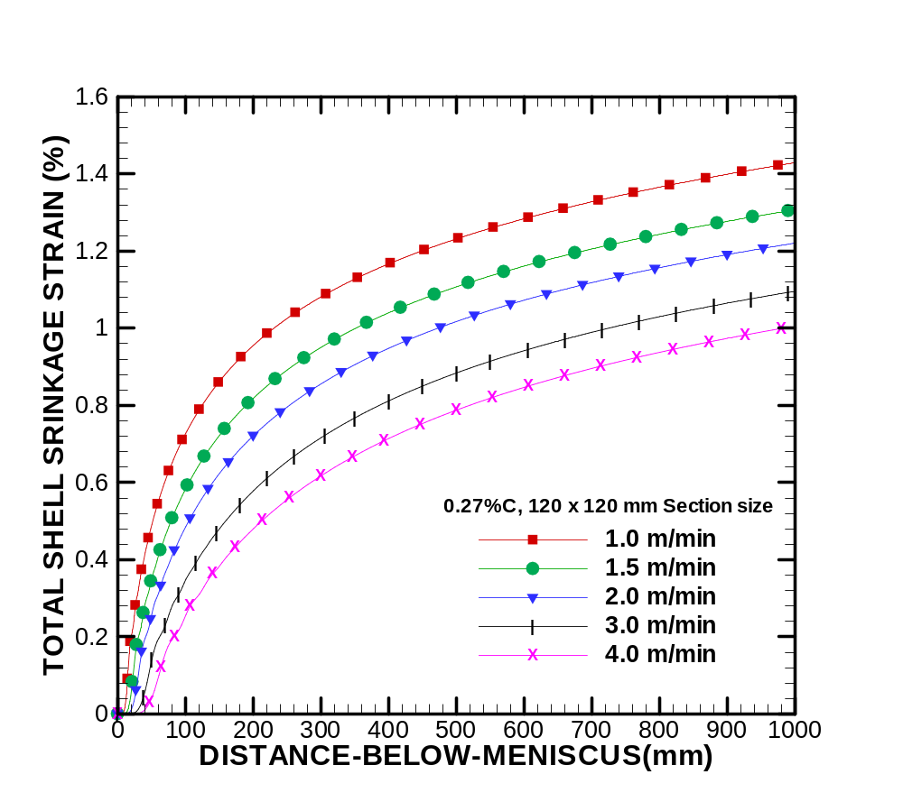
Fig. 6: Effect of casting speed on steel shell shrinkage with ferrostatic pressure
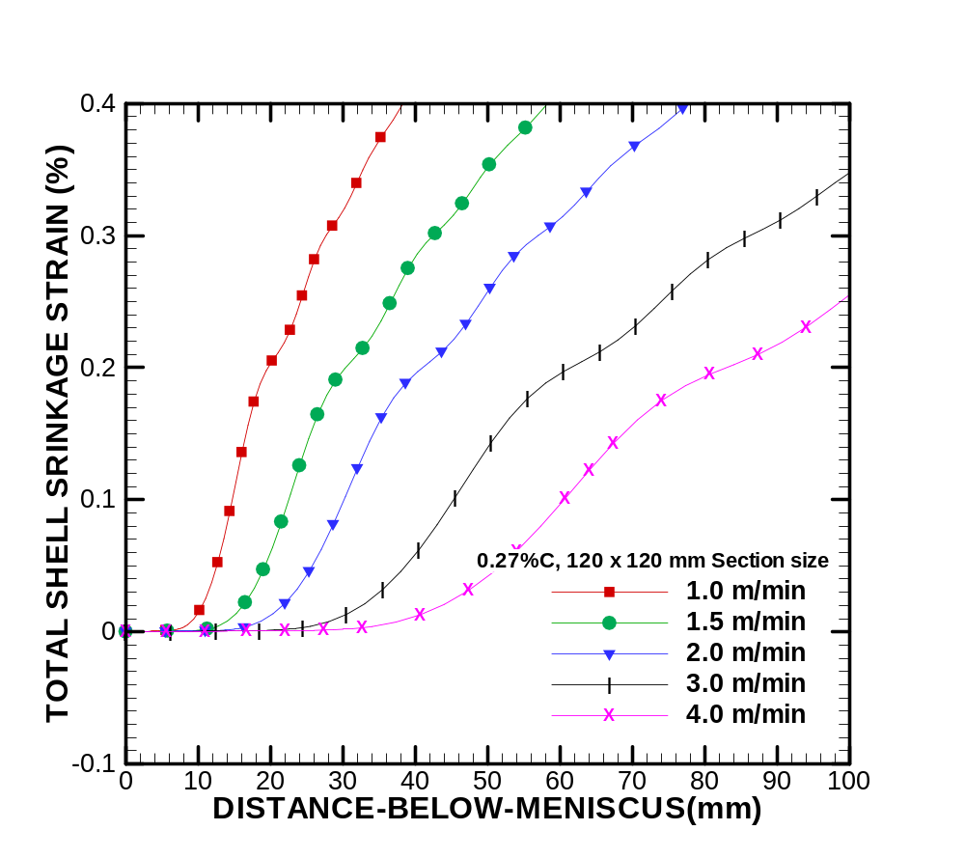
Fig. 7: Detail of the shell shrinkage near the meniscus for high heat flux and ferrostatic pressure
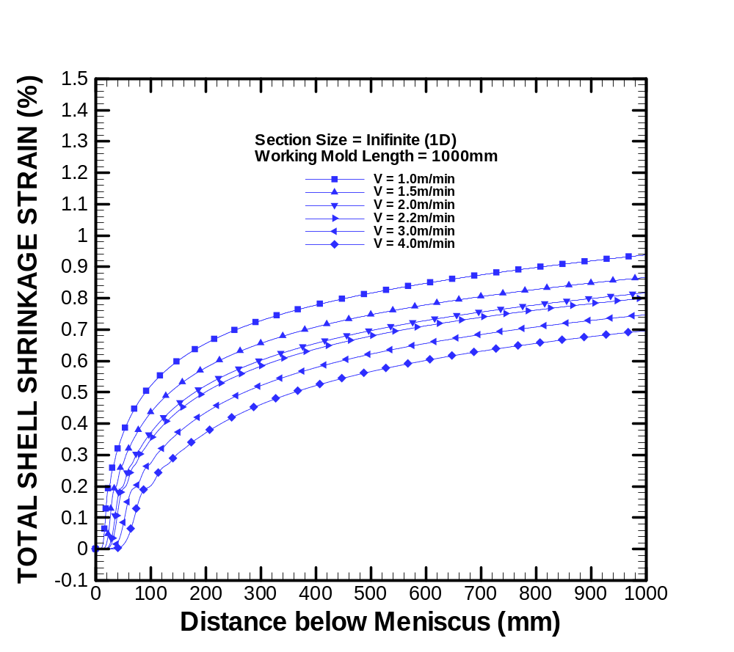
Fig. 8: Effect of casting speed on Shell shrinkage for low Heat flux with ferrostatic pressure
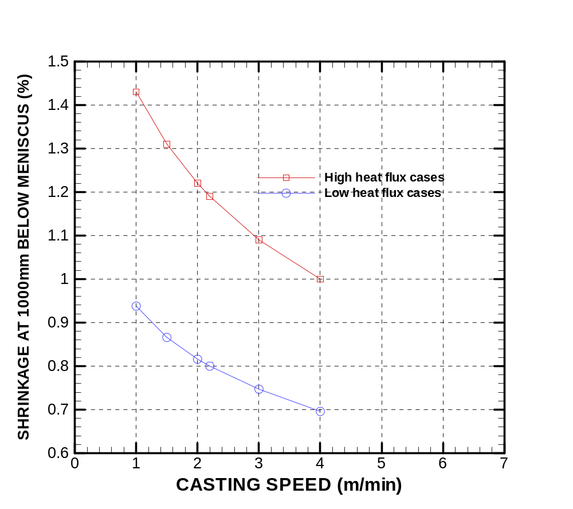
Fig. 9: Shrinkage at 1000mm below Meniscus for Low and High Heat Fluxes with ferrostatic pressure

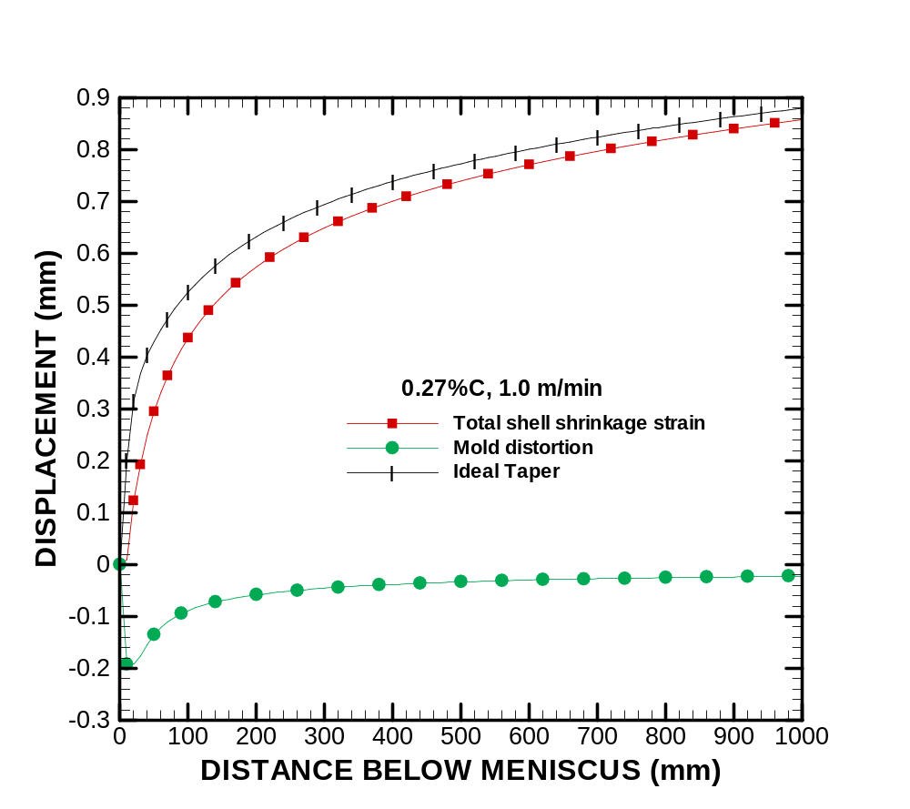
Fig. 10: Mold Wall distortion, shell shrinkage and Ideal taper for high heat flux, 0.27%C and 1.0 m/min with ferrostatic pressure
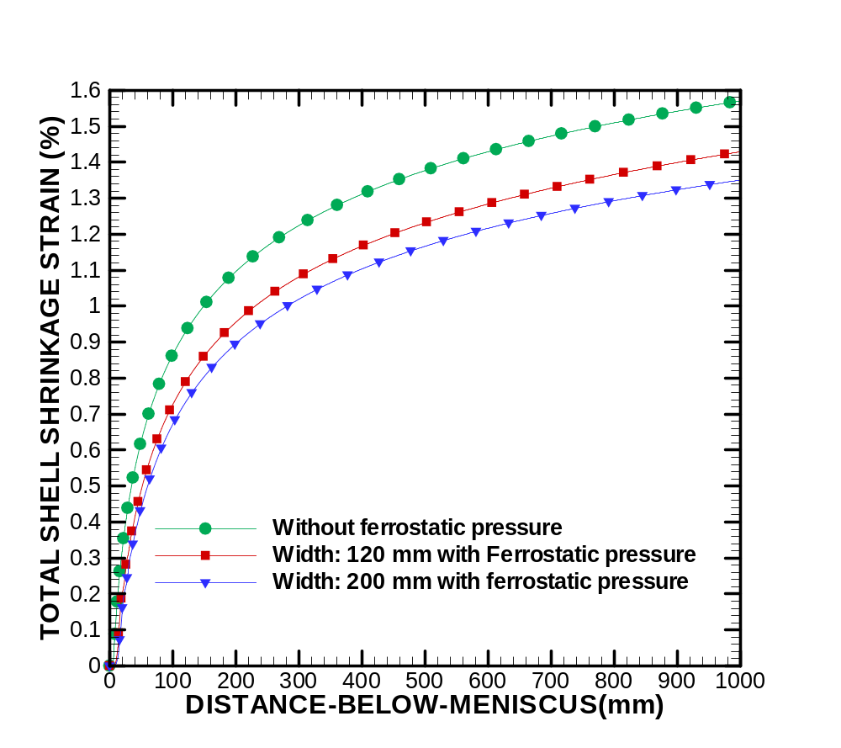
Fig. 11: Effect of ferrostatic pressure in shell shrinkage

