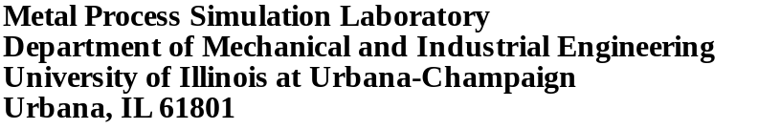

Ideal taper prediction for high speed billet casting. Part I

Chunsheng Li, Brian G. Thomas, and Claudio Ojeda

Continuous Casting Consortium

Report
2002

Submitted to

Accumold
AK Steel
Columbus Stainless
Hatch Associates/SMS

October 15, 2002

ideal taper prediction for high speed billet casting
Chunsheng Li, Brian G. Thomas, and Claudio Ojeda
1206 W. Green St.
Urbana, IL 61801
217-244-2859, cli1@uiuc.edu

abstract
Ideal taper of one-piece copper billet molds was predicted using a 2-D finite element elastic-viscoplastic thermal-stress model of the continuous casting of steel. Predictions by the full 2D thermal-stress model, (CON2D) a 1D-slice-domain thermal-stress model (CON2D) and a 1D heat-transfer model (CON1D) are compared. Ideal tapers are then predicted for different casting speeds, working mold lengths and section sizes. A further study is conducted to investigate the effect of heat flux curve shape and steel grade.
introduction
During continuous casting, mold taper plays an important role to ensure good contact and heat exchange between the mold wall and shell surface, which controls shell growth uniformity, especially at high casting speeds. Several efforts have been conducted to predict ideal mold taper in previous work.^{[1-8]}. These include simulations of square billets, ^{[4, 5, 7, 9]}, round billets, ^{[1]}; and slabs^{[2, 3]}. None of the previous work has systematically investigated the effect of casting conditions on ideal taper.
model description
In this work, a 2D finite-element elastic-viscoplastic thermal-stress model^{[10, 11]} was applied to investigate ideal taper of square billet molds. Two simulation domains were used, the 2D L-shaped domain (shown in Fig. 1) and a 1D slice domain (shown in Fig. 2), representing the behavior of a longitudinal slice through the centerline of the shell.
The model solves a 2D finite-element discretization of the transient heat conduction equation in a Lagrangian reference frame that moves down through the caster with the solidifying steel shell. The nonlinear enthalpy gradients that accompany latent heat evolution were handled using a spatial averaging method by Lemon ^{[12]}. It adopts a three-level time-stepping method by Dupont ^{[13]}.
The force equilibrium, constitutive, and strain displacement equations in this 2-D slice through the shell are solved under a condition of generalized plane strain in the casting direction ^{[14]}.
The total strain increment, {Δε}, is composed of elastic, {Δε_{e}}, thermal, {Δε_{th}}, inelastic strain, {Δε_{in}}, and flow strain, {Δε_{flow}}, components. Thermal strain due to volume changes caused by both temperature differences and phase transformations is calculated from the thermal linear expansion (TLE) of the material, which is based on density measurements.
(1)
A unified constitutive model is used here to capture the temperature- and strain-rate sensitivity of high temperature steel. The instantaneous equivalent inelastic strain rate 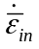 is adopted as the scalar state function, which depends on the current equivalent stress, 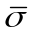, temperature, , the current equivalent inelastic strain, 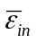, which accumulates below the solidus temperature, and carbon content of the steel. When the steel is mainly austenite phase, (%γ >90%), Model III by Kozlowski ^{[15]} was applied. This function matches tensile test measurements of Wray ^{[16]} and creep test data of Suzuki ^{[17]}. When the steel contains significant amounts of soft delta-ferrite phase (%δ >10%), a power-law model is used, which matches measurements of Wray above 1400 ºC ^{[18]}. Fig. 3 shows the accuracy of the constitutive model predictions compared with stresses measured by Wray ^{[19]} at 5% strain at different strain rates and temperatures. This figure also shows the higher relative strength of austenite, which is important for stress development in the solidifying shell discussed later. The standard von Mises loading surface, associated plasticity and normality hypotheses in the Prandtl-Reuss flow law is applied to model isotropic hardening of these plain carbon steels ^{[20]}.
As a fixed-grid approach is employed, liquid elements are generally given no special treatment regarding material properties or finite element assembly. To enforce negligible shear stress in the liquid, the following constitutive equation is used to provide an extremely rapid creep strain rate in every element containing any liquid, (ie., 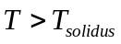).
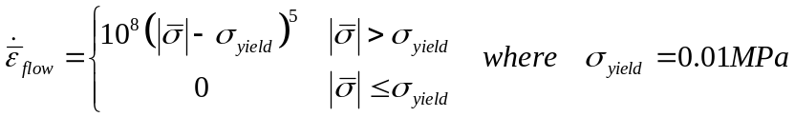 (2)
The same Prandtl-Reuss relation used for the solid is adopted to expand this scalar strain rate to its multi-dimensional vector. This fixed-grid approach avoids difficulties of adaptive meshing and allows strain to accumulate in the mushy region, which is important for the prediction of hot tear cracks. As in the real system, the total mass of the liquid domain is not constant, and the inelastic strain accumulated in the liquid region represents mass transport due to fluid flow in and out of the domain, so is denoted as "flow strain". Positive flow strain indicates fluid feeding into the simulated region.
Ferrostatic pressure due to gravity acting on the internal liquid pool, 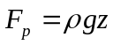, is applied as an internal boundary condition. Each three-node element containing exactly two nodes just below the solidus temperature is subjected to a load pushing toward the mold wall.
The mold wall provides support to the solidifying shell before it reaches the mold exit. A proper mold wall constraint is needed to prevent the solidifying shell from penetrating the mold wall, but allowing the shell to shrink freely. The present method developed by Moitra ^{[10, 14]} is based on penalty method. It allows the shell deform freely at the beginning of each step and repeatedly constraint half of the penetrating nodes until no penetration occur.
A generalized plane strain assumption is applied in the casting direction for the L-shaped domain simulation and also in the y-direction for the slice domain simulation, as shown in Fig. 2. This accurate assumption is believed to closely approximate the true 3-D stress and strain state in long domains involving thermal stress, such as the present case.
simulation conditions
The instantaneous heat flux down the mold assumed in this work is given in Eq. (3) and Fig. 5. It is found by differentiating the average heat flux curve, shown in Fig. 4, which is based on fitting measurements at many different plants ^{[21]} with total mold residence time. Heat flux is assumed to be uniform around the perimeter of the billet surface in order to simulate the perfect contact between the shell and mold that is expected for ideal taper conditions.
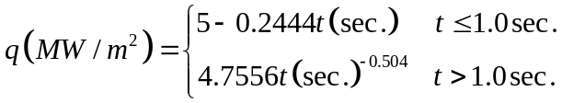 (4)
Initial simulations were performed for a 0.27%C steel (see phase transformation temperatures in Table 1) solidifying in molds of 120, 175, and 250 mm square cross section and working mold lengths of 500, 700, and 1000 mm (600, 800, and 1100 mm total length). Details of the two-dimensional transient finite element meshes are given in Table 2.
Subsequent simulations were performed using 1-D slice domains in order to investigate the effect of heat flux profile, steel grade, and powder composition on ideal taper. For these simulations, the total heat flux was determined from:
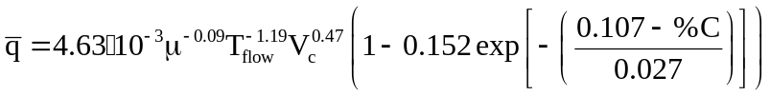 (5)
where is the mean heat flux (MW/m²), μ is the powder viscosity at 1300 ºC, (Pa-s), T_{flow} is the melting temperature of the mold flux (ºC), V_{c} is the casting speed (m/min), and %C is the carbon content. This equation is a fit of many measurements under different conditions at a typical slab caster ^{[22]}. It quantifies the well-known facts that heat flux drops for peritectic steels (near .107%C) and for mold powders with high solidification temperatures, (which hence form a thicker insulating flux layer against the mold wall). There is also a very slight drop in heat flux for mold powders with higher viscosity.
RESULTS
Taper prediction models
The shrinkage predictions using four different modeling methods are compared in Fig. 4. The most accurate simulation is the fully two-dimensional transient prediction with the CON2D model on the L-shaped mesh, which shows a greater amount of percentage shrinkage of the corner of a slice through the center (midface). This is understandable, due to the lower corner temperature. If the corner were the same temperature as the midface, the two results would be the same.
The full 2-D midface centerline predictions compare very closely with CON2D predictions using a slice-domain in a condition of generalized plane strain. The only difference is a “glitch” in the full 2D simulation at about 250mm, which is due to slight numerical inaccuracies in the contact algorithm. This shows that the 1-D slice domain is an accurate and economical method to predict behavior of the center region.
Two further shrinkage predictions are shown from CON1D predictions based on thermal strain. The surface temperature based method is a rough approximation of the center behavior. The Dippenaar method produces a more accurate prediction of the center slice, except that it neglects plasticity. This causes it to overpredict the center slice shrinkage. This error almost compensates for the corner effect, so the result compares closely with the CON2D corner prediction. This match might be coincidental, however, so further simulations were performed using only the CON2D method.
Effect of Mold Distortion
The mold distorts away from the shell, especially at and just below the meniscus. This should be taken into account when designing the mold taper. Specifically, the local distortion of the mold away from the shell, relative to that at the meniscus, should be added to the wall position, in order to find the mold taper at ambient temperature. Elastic distortion of a billet mold is estimated with the following equation:
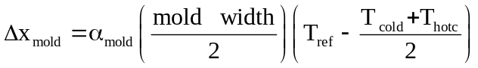 (6)
where Δx_{mold} is the mold distortion (mm), α_{mold} is the thermal expansion coefficient of the copper (1.6x10⁻⁵), mold width is in mm, T_{ref} is average copper temperature at the meniscus, T_{cold} and T_{hot} are the cold and hot face temperatures at any given distance below the meniscus. This simple equation matches 3D elastic finite-element model calculations of a billet mold ^{[23]}.
A linear taper of 0.75%/m was imposed during the simulations, in addition to mold distortion using Eq. 7, and shown in Fig. 5. After the ideal shrinkage prediction was computed, this simulation was repeated imposing a mold wall position with this ideal shape (hot taper). This prevented shell bulging inside the mold and eliminated the corner gaps. As shown in Fig. 11B, the center of the shell face is pushed back by the mold wall, generating a “flat” shape, (actually wavy, due to the +/- 0.1mm numerical uncertainty in the contact algorithm.) This figure also shows that the corner shrinkage behavior is virtually identical. This is due to the assumption of uniform heat flux around the mold perimeter, and thus validates the methodology.
Calculations of the correction needed for mold distortion have revealed that its magnitude (relative to the meniscus) is on the order of 0.06% away from the shell 100mm below the meniscus and 0.04% toward the shell in the lower portions of the mold. Thus, the effect is to slightly increase the nonlinearity needed for the taper to match the shell shrinkage. Mold distortion is neglected in the remainder of this work.
Effect of mold length
Fig. 6 compares the ideal taper (based on corner shrinkage and neglecting mold distortion) for the nine combinations of section sizes and working mold lengths at 2.2m/min casting speed. Table 4 shows that the shrinkage is governed by the heat flux profile. Shrinkage in this work is considered as %/mold unless otherwise specified. Longer molds need more taper (per mold), owing to the extra cooling from the extra dwell time, but need less taper (per meter) owing to decreasing heat flux further below the meniscus.
For a given set of conditions, the shrinkage profiles for different mold lengths all collapse onto a single curve. Results for any mold length are given simply by truncating the curve at the desired working mold length. This is due to the universal heat flux function assumed for all cases. This result demonstrates consistency of the computations. The remaining simulations are all performed on the same mold length.
Effect of section size
Fig. 7 also shows that increasing section size decreases the ideal mold taper. This is because this increases the relative importance of the corner, with its increased shrinkage. Fig. 8 shows the extent of the colder corner, which accounts for the increased shrinkage there. This figure, and the mold exit values tabulated in Table 4, also includes the slice domain results, which correspond to an infinite section size (approximating a slab). If a gap is allowed to form in the corner, then its temperature will not drop, and the corner shrinkage will be similar to the center slice. This would decrease the ideal taper to match the slab case. Thus, there is a range of ideal tapers where the shell shrinkage should be able to accommodate variations in taper. The difference between the 1-D slice domain results (infinite section size) and the actual section size of concern represents this range.
Effect of casting speed
The effect of casting speed is shown in Figs. 9 a, b, c, and d, for different section sizes, using CON2D with the 2D L-shaped domain. The results at mold exit are summarized in Fig. 10 and tabulated in Table 4 for a typical case (1D slice = wide section). Naturally, higher casting speed produces less dwell time and consequently thinner shell, which has less shrinkage, so requires less taper. The decrease in required taper is not as much as might be expected, however, due to the higher average mold heat flux, which lowers the shell surface temperature (for a given time).
The shape of all curves is similar. As for all of the results, significantly more mold taper is required just below the meniscus than near mold exit. A mold wall shape such as a parabolic taper is therefore important.
Note that an increase in slope occurs near the beginning of each curve. This corresponds to the sharp drop in the heat flux (from linear to exponential) at 1 second. This effect suggests that the shape of the heat flux curve has a great influence on the ideal taper.
Effect of Heat Flux Curve Shape
Shell shrinkage is quite sensitive to minor changes in the heat flux profile, particular near the meniscus. For example, Fig. 11 shows two similar heat flux curves with the same average, but with slightly different shapes. One has slightly higher heat flux near the top of the mold, while the other has slightly higher heat flux in the lower portions of the mold. Fig. 12 shows the corresponding temperature profiles, which are colder for the higher meniscus heat flux case. Fig. 13 shows that the corresponding shrinkage profiles differ much more. Specifically, the case with a higher initial heat flux, followed by a sharper drop produces more shrinkage at mold exit. This means that ideal taper depends on both the magnitude and shape of the heat flux curve. Because heat flux near the top of the mold is difficult to control, it would be wise to design the mold with some means to accommodate casting with non-optimal taper in that region.
Effect of Steel Grade
Changing steel grade affects taper in two main ways. Firstly, it affects the mold heat flux, which tends to be lower for the peritectic steels, mainly due to deeper oscillation marks. Secondly, it changes the steel thermal and mechanical properties, most notably the thermal expansion coefficient, which is larger for the peritectic steels. These two effects tend to offset each other somewhat.
To quantify the effect of steel composition, five simulations were conducted to using the 1D slice domain (ie. large section size). First, heat flux for the different grades was obtained, based on measurements conducted for typical flux casting, using the experimentally-fitted Eq. 4, (casting at 1.5 m/min in an 800-mm working mold length), using mold powders typically used for each grade. This equation features a maximum drop of about 20% in mold heat flux for peritectic steels, as shown in the conditions given in Table 3 and Fig. 14. (This is due to a combination of the deeper oscillation marks for this steel grade and the higher solidification temperature of the mold flux used for these grades). This drop corresponds roughly to the drop in heat flux measured for billet casting. These heat flux values are consistent with those assumed for the 0.27%C steel for similar casting conditions (comparing Tables 3 and 4).
The effects of steel grade, and its associated heat flux, on shell temperature, shell thickness, and shrinkage are shown in Figs. 15, 16, and 17. These figures show that the lower heat flux produces a hotter shell surface temperature. This effect appears to outweigh the importance of the extra shrinkage of the peritectic steels. Thus, peritectic steels experience less shrinkage and require less taper than either low or high carbon steels.
The low carbon steels (<.08%C) have extra plastic strain, owing to their microstructure being in the soft, rapidly-creeping delta phase. This extra creep generated in the solid tends to lower the amount of shrinkage experienced by these grades (note the difference between con1d results for pure thermal shrinkage and CON2D results with this effect). The net effect is that low carbon steels experience both heat flux and shell shrinkage that is similar to that of higher carbon steels (eg. 0.47%), in spite of their greater average thermal expansion.
The shrinkage for all five grades is compared in Fig. 18 at mold exit, (800 mm below the meniscus). This figure also shows the shrinkage that occurs only between 50mm and mold exit, and indicates that most of the shrinkage occurs in the top 50 mm below the meniscus. The shrinkage between 50mm and mold exit shows the expected slight drop for the peritectic grade, as discussed above. However, most of the shrinkage occurs very near the top of the mold. This is likely the reason for the great sensitivity of the shrinkage to the heat flux (see previous section). The consequence for insufficient taper in this region is simply to have a slight corner gap, which becomes hotter and compensates with less shrinkage. Thus, errors in taper in this initial region are likely not to be as critical.
CONCLUSIONS
Computational models have been developed and applied to predict ideal taper during continuous casting of steel billets. The models quantify the ideal taper under a variety of conditions and the predictions include the following:
1. More taper is needed near the top of the mold, such as achieved using parabolic taper.
2. Mold distortion has a minor influence on ideal taper, so long as there is no permanent plastic deformation.
3. As casting speed increases, shrinkage decreases (for a given section size and heat flux profile).
4. Mold length affects the taper only by extending the nonlinear curve.
5. As section size increases, shrinkage decreases (for a given heat flux profile).
6. Mold taper depends mainly on the heat flux profile, which in turn depends on the casting speed and interface conditions (powder, steel grade, etc.).
7. Peritectic steels generally require slightly less taper than either low or high carbon steels, owing to their lower heat flux.
8. Mold powders with higher solidification temperature have lower heat flux (compared with both oil lubrication or low solidification temperature powders) and consequently have less shrinkage and less ideal taper (other conditions staying the same).
references
1. M.R. Ridolfi, B.G. Thomas, G. Li, U.D. Foglia, "The optimization of mold taper for the Ilva-Dalmine round bloom caster," Continuous Casting, Vol. 9, 1997, 259.
2. B.G. Thomas and W.R. Storkman, "Mathematical Models of Continuous Slab Casting to Optimize Mold Taper," Modeling and Control of Casting and Welding Process, (Palm Coast, FL), 1988, 287~297, 085.
3. B.G. Thomas, W.R. Storkman and A. Moitra, "Optimizing taper in continuous slab casting molds using mathematical models," Proceedings 6th International Iron and Steel Congress, (Nagoya, Japan), ISIJ, Vol. 3, 1990, 348-355, 038.
4. B. Wang, B.N. Walker and I.V. Samarasekera, "Shell Growth, Surface Quality and Mould Taper Design for High-Speed Casting of Stainless Steel Billets,",, 1999,
5. S. Chandra, J.K. Brimacombe and I.V. Samarasekera, "Mould-strand interaction in continuous casting of steel billets, Part 3: Mould heat transfer and taper," Ironmaking and Steelmaking, Vol. 20 (2), 1993, 104.
6. S.-i. Deshimaru, S. Omiya, H. Mizota, M. Yao, M. Maeda, T. Imai, "Effect of 3-Dimensional Mold-Taper of Narrow Face on the Heat Extraction," 107th ISIJ Meeting, 1984, 088.
7. R.J. Dippenaar, I.V. Samarasekera and J.K. Brimacombe, "Mold Taper in Continuous Casting Billet Machines," ISS Transactions, Vol. 7, 1986, 31.
8. M. Larrecq, J. Petegnief, M. Wanin, P. Antoine, J. Foussal, "Heat Transfer in the Mould of the Bloom Caster at Usinor Neuves-Maisons Determination of Optimal Taper,",, 1982,
9. I.A. Bakshi, J.L. Brendzy, N. Walker, S. Chandra, I.V. Samarasekera, J.K. Brimacombe, "Mould-strand interaction in continuous casting of steel billets -- Part 1 Industrial trials, Part 2 Lubrication and oscillation mark formation, Part 3 Mould heat transfer and taper," Ironmaking and Steelmaking, Vol. 20 (1), 1993, 54.
10. A. Moitra, B.G. Thomas and H. Zhu, "Application of a thermo-mechanical model for steel shell behavior in continuous slab casting," 76th Steelmaking Conference, (Dallas, TX), Warrendale, PA, Vol. 76, 1993, 657, 039.
11. H. Zhu, "Coupled Thermal-Mechanical Finite-Element Model with Application to Initial Solidification," Ph.D. Thesis, University of Illinois at Urbana-Champaign, 1996.
12. E. Lemmon, "Multi-dimentional Integral Phase Change Approximations for Finite-Element Conduction Codes," in Numerical Methods in Heat Transfer, Vol. 1, R.W. Lewis, K. Morgan and O.C. Zienkiewicz, eds., John Wiley & Sons, 1981, 201-213.
13. T. Dupont, G. Fairweather and J.P. Johnson, "Three-Level Galerkin Methods for Parabolic Equations," SIAM Journal on Numerical Analysis, Vol. 11 (2), 1974, 392-410.
14. A. Moitra, "Thermo-Mechanical Model of Steel Shell Behavior in Continuous Slab Casting," Ph.D. Thesis, University of Illinois at Urbana-Champaign, 1993.
15. P.F. Kozlowski, B.G. Thomas, J.A. Azzi, H. Wang, "Simple Constitutive Equations for Steel at High Temperature," Metallurgical and Materials Transactions, A, Vol. 23 (March), 1992, 903-918.
16. P.J. Wray, "Effect of Crabon Content on the Plastic Flow of Plain Carbon Steels at Elevated Temperatures," Metallurgical and Materials Transactions A, Vol. 13A (January), 1982, 125-134.
17. T. Suzuki, K.H. Tacke, K. Wunnenberg, K. Schwerdtfeger, "Creep Properties of Steel at Continuous Casting Temperatures," Ironmaking and Steelmaking, Vol. 15 (2), 1988, 90-100.
18. B.G. Thomas and J.T. Parkman, "Simulation of Thermal Mechanical Behaviour During Initial Solidification," Thermec '97 International Conference on Thermomechanical Processing of Steel and Other Materials, (Wollongong, Australia), TMS, Warrendale, PA, Vol. II, 1997, 2279-2285, 030.
19. P.J. Wray, "Plastic Deformation of Delta-Ferritic Iron at Intermediate Strain Rates," Metallurgical and Materials Transactions A, Vol. 7A (November), 1976, 1621-1627.
20. J. Lemaitre and J.L. Chaboche, Mechanics of Solid Materials, Cambridge University Press, 1990, 556.
21. C. Li and B.G. Thomas, "Maximum Casting Speed for Continuous Cast Steel Billets Based on Sub-mold Bulging Computation," 85th Steelmaking Conference, (Nashiville, TN), ISS-AIME, Warrendale, PA, Vol. 85, 2002, 109-130.
22. C. Cicutti, M. Valdez and T. Perez, "Mould Thermal Evaluation in a Slab Continuous Casting Machine," 85th Steelmaking Conference, (Nashville, TE, USA), Iron and Steel Society, Inc. (USA), Vol. 85, 2002, 97-107.
23. I.V. Samarasekera and J.K. Brimecombe, "Thermal and Mechanical Behaviour of Continuous-Casting Billet Moulds," Ironmaking and Steelmaking (1), 1982,
Table 4: Material Transformation Temperatures
Steel Composition (wt%) | 0.27C, 1.52Mn, 0.34Si, 0.015S, 0.012P
Liquidus Temperature (ºC) | 1500.72
70% Solid Temperature (ºC) | 1477.02
90% Solid Temperature (ºC) | 1459.90
Solidus Temperature (ºC) | 1411.79
Austenite→α-Ferrite Starting Temperature (ºC) | 781.36
Eutectoid Temperature (ºC) | 711.22

Table 5: Simulation Conditions (standard conditions in bold)
Billet Section Size (mmmm) | 120120, 175175, 250250
Working Mold Length (mm) | 500, 700, 1000
Total Mold Length (mm) | 600, 800, 1100
Taper (%m) | 0.75 (on both face)
Time to turn on ferrostatic pressure (sec.) | 0.3
Mesh Size (mmmm) | 0.10.1 - 1.41.0
Number of Nodes (varies with section size) | 7381, 10797, 15433
Number of Elements (varies with section size) | 7200, 10560, 15120
Time Step Size (sec.) | 0.001 - 0.5
Pouring Temperature (ºC) | 1540.0

Table 6: Steel Grade Investigation
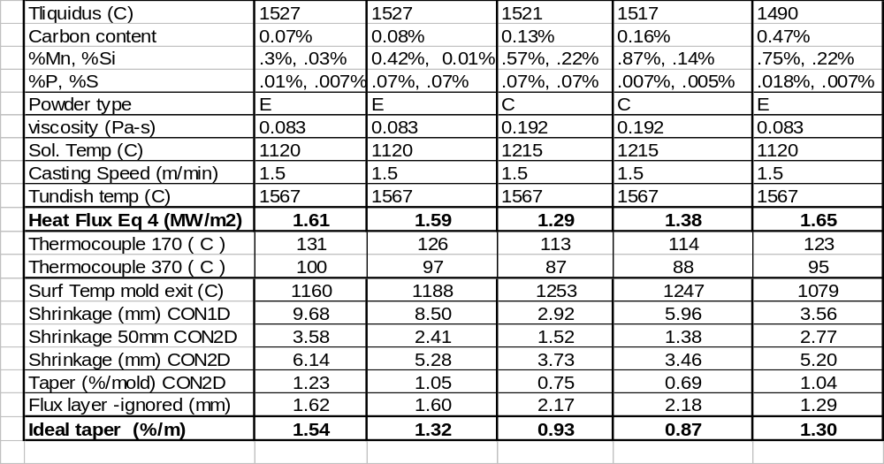
Table 7: Heat Flux Effect on Ideal Taper
 |  | Dwell Time  (sec.) | Mold Heat Flux (MW/m²) | Shrinkage at Mold Exit (%) | Ideal Taper at Mold Exit (%/m)
Working Mold Length (mm)  (1D, 2.2m/min casting speed) | 500 | 13.6 | 2.23 | 0.68 | 1.36
Working Mold Length (mm)  (1D, 2.2m/min casting speed) | 700 | 19.1 | 1.92 | 0.74 | 1.06
Working Mold Length (mm)  (1D, 2.2m/min casting speed) | 1000 | 27.3 | 1.64 | 0.80 | 0.80
Section Size (mm)  (1000mm working mold length, 2.2m/min casting speed) | 120 | 27.3 | 1.64 | 1.13 | 1.13
 | 175 | 27.3 | 1.64 | 1.06 | 1.06
 | 250 | 27.3 | 1.64 | 0.99 | 0.99
 | ∞ (1D) | 27.3 | 1.64 | 0.80 | 0.80
Casting Speed (m/min)  (1D, 1000mm working mold length) | 1.0 | 60.0 | 1.14 | 0.94 | 0.94
Casting Speed (m/min)  (1D, 1000mm working mold length) | 1.5 | 40.0 | 1.38 | 0.87 | 0.87
Casting Speed (m/min)  (1D, 1000mm working mold length) | 2.2 | 27.3 | 1.64 | 0.80 | 0.80
Casting Speed (m/min)  (1D, 1000mm working mold length) | 4.0 | 15.0 | 2.14 | 0.70 | 0.70

FIGURES
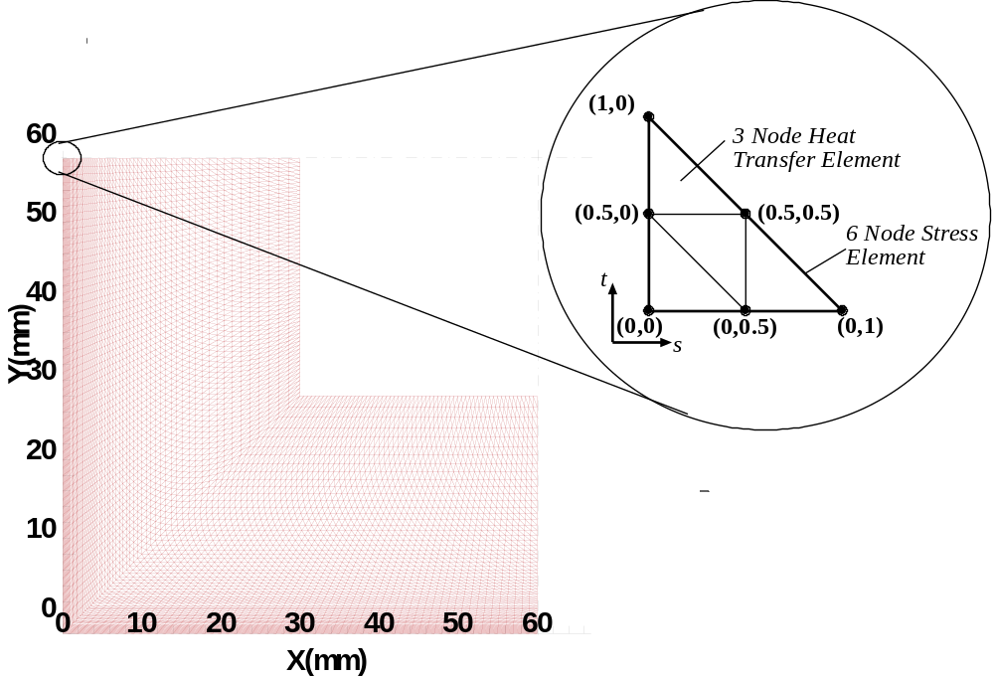
Fig. 19: 2D L Shape Simulation Domain
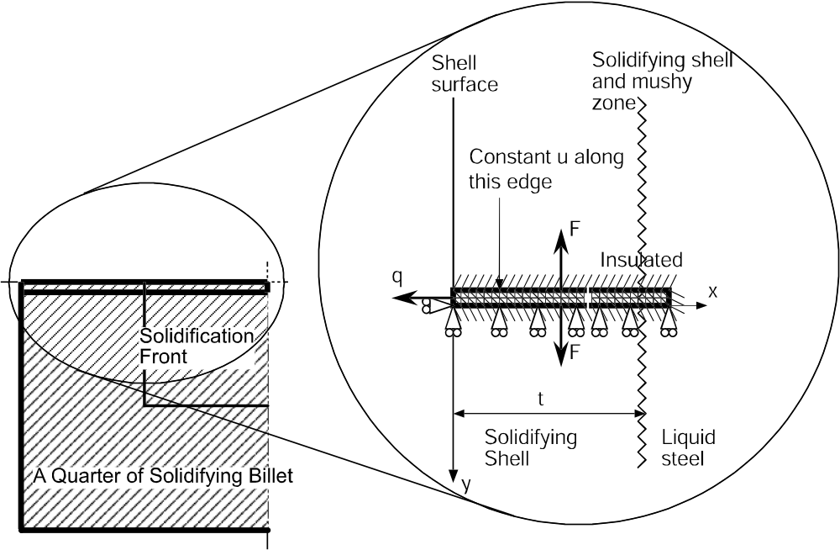
Fig. 20: 1D Slice Simulation Domain
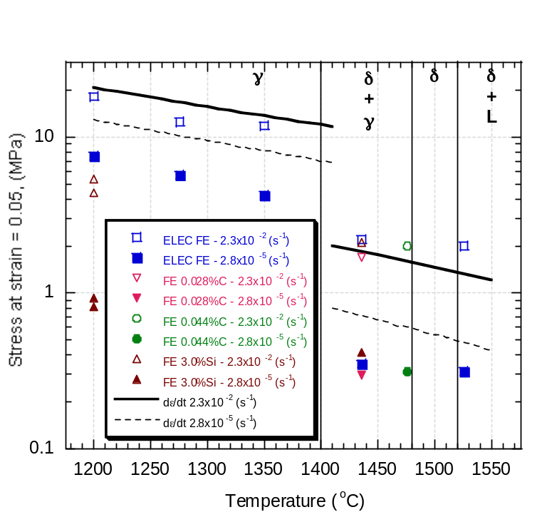
Fig. 21: Comparison of predicted and measured stress ^{[19]}
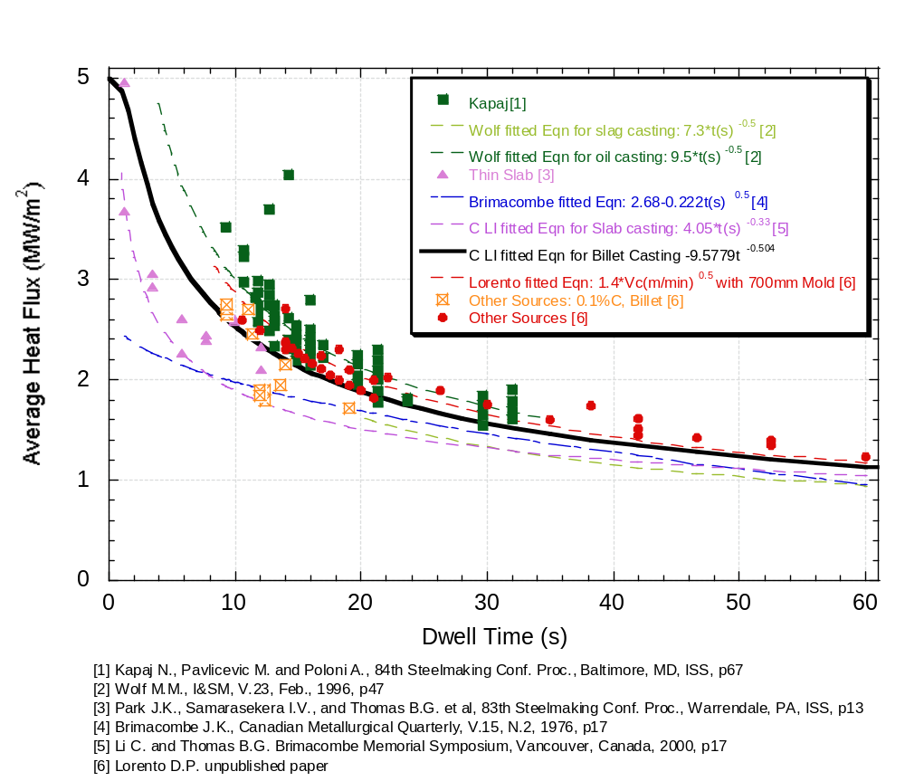
Fig. 22: Measured Average Heat Flux and Fitted Average Heat Flux Curve
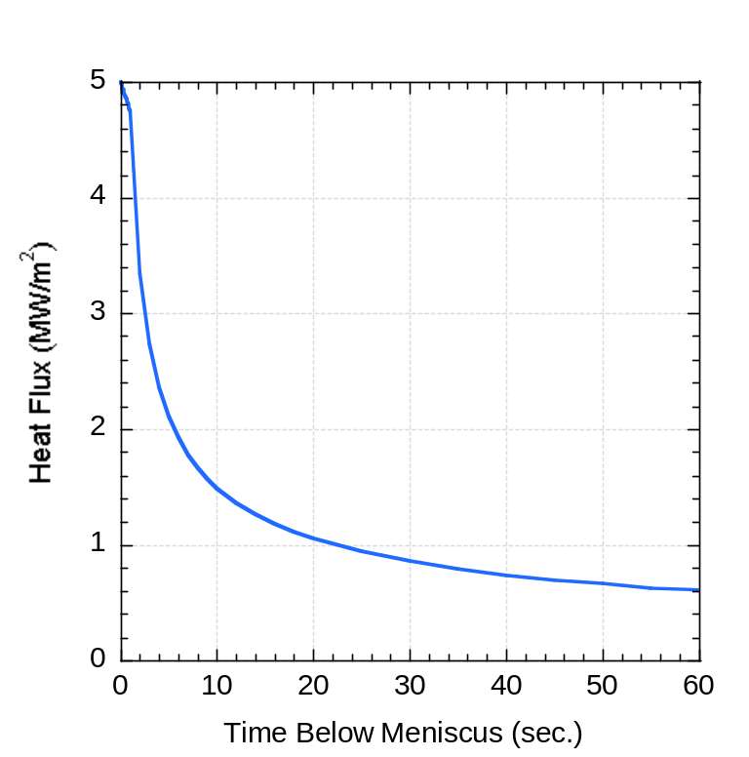
Fig. 23: Instantaneous Heat Flux Curve
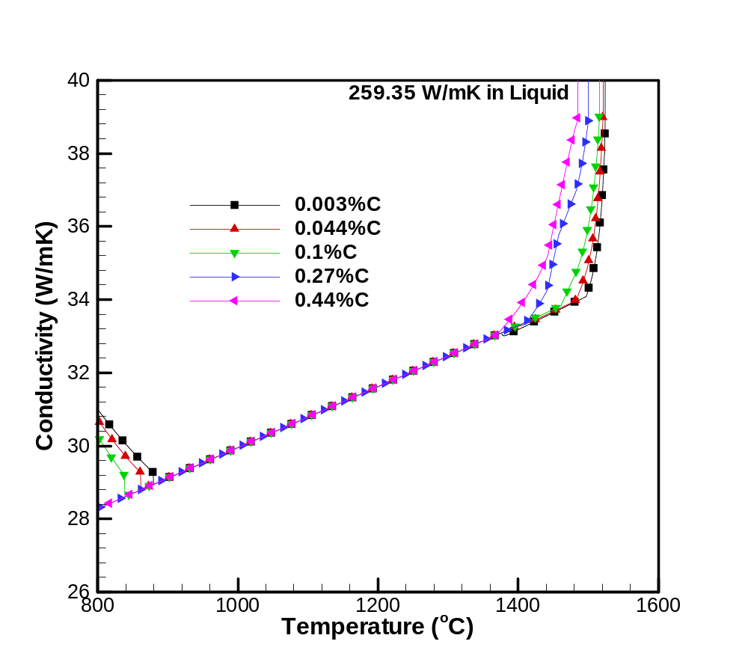
Fig. 24: Thermal Conductivity for 0:27%wtC Plain Carbon Steel
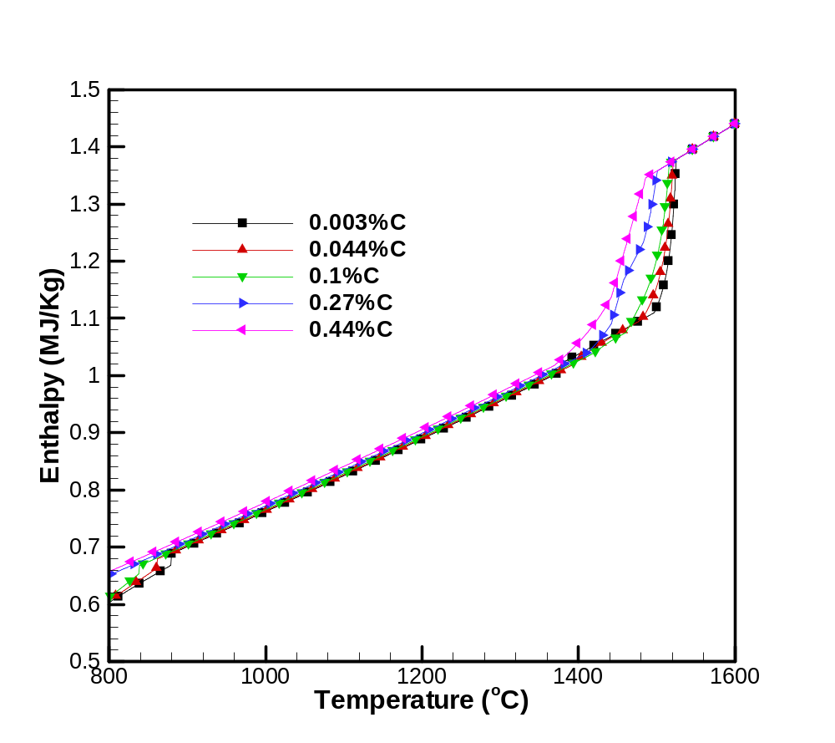
Fig. 25: Enthalpy for 0:27%wtC Plain Carbon Steel
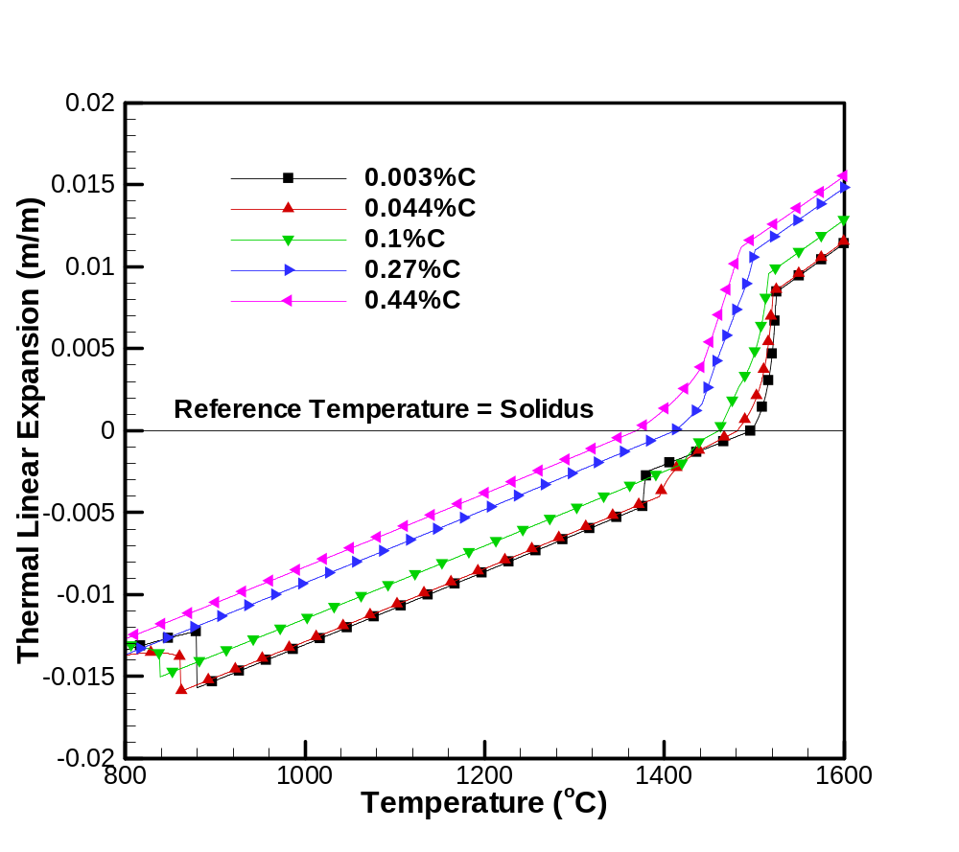
Fig. 26: Thermal Linear Expansion for 0:27%wtC Plain Carbon Steel
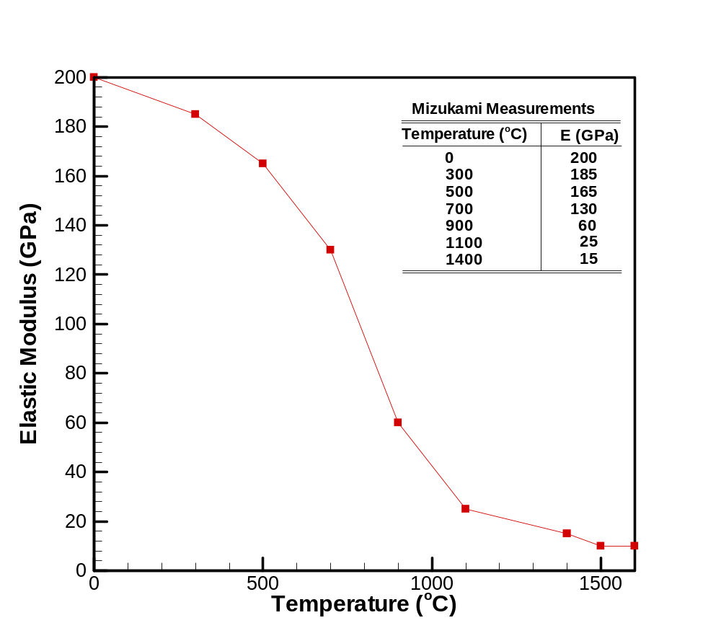
Fig. 27: Elastic Modulus for Plain Carbon Steel
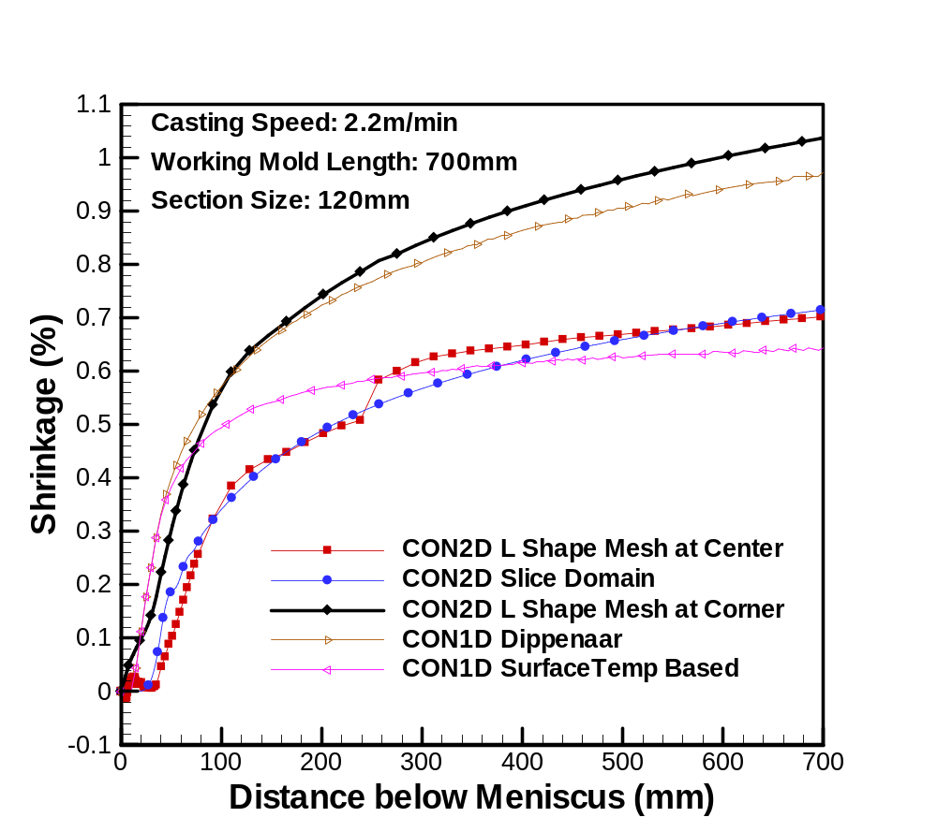
Fig. 28: Shrinkage Predictions by Various Models (Standard Conditions in Table 8)
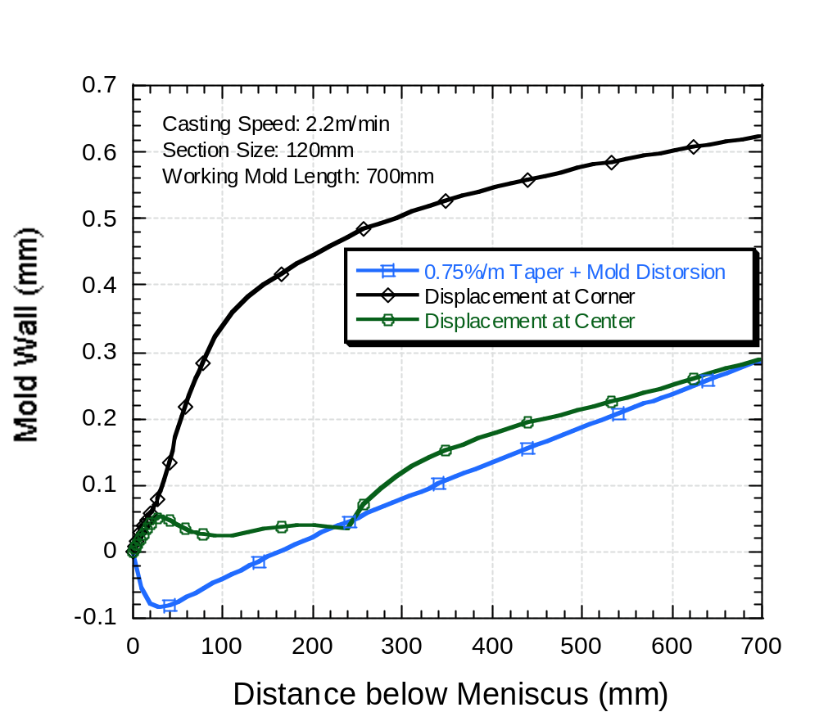
Fig. 29: Mold Wall Positions Assumed for Test Simulations of the Effect of Mold Distortion and Interfacial Gap on Ideal Taper
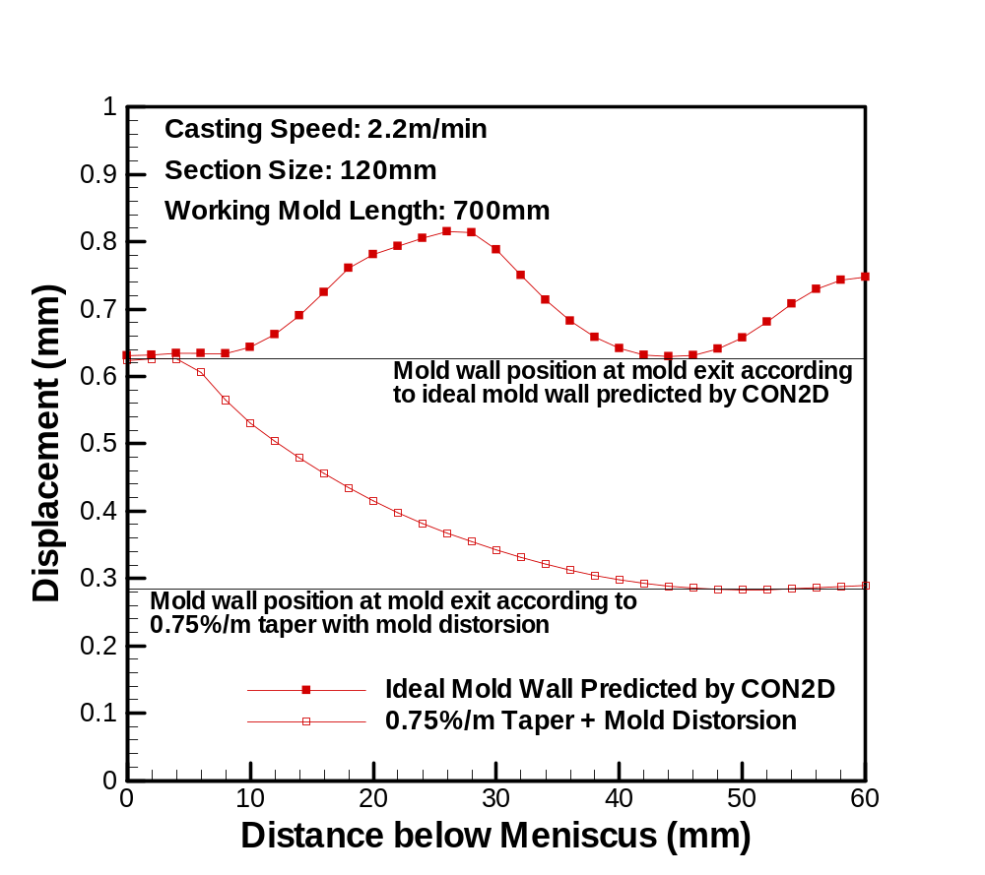
Fig. 30B: Shell Distortion at Mold Exit for the 2 Wall Profiles in Fig. 31
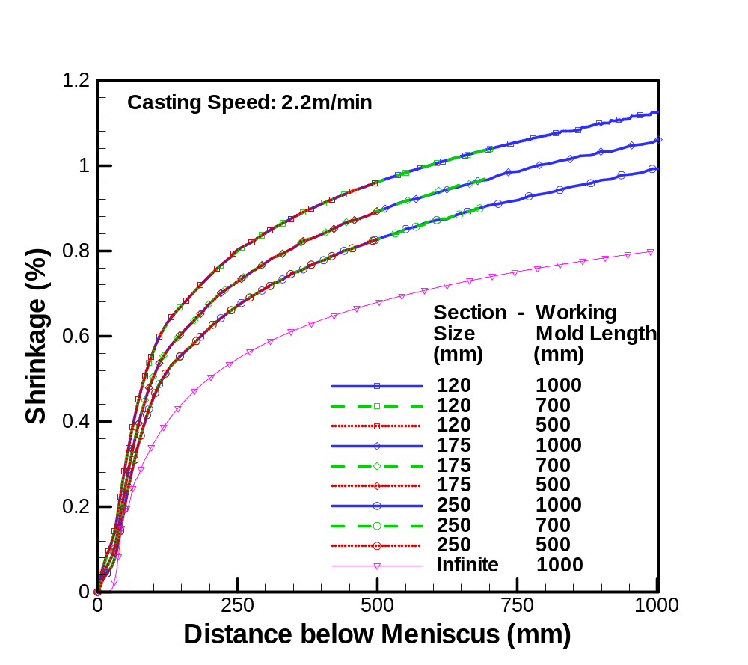
Fig. 32: Effect of Mold Length and Billet Section Size on Ideal Shell Shrinkage
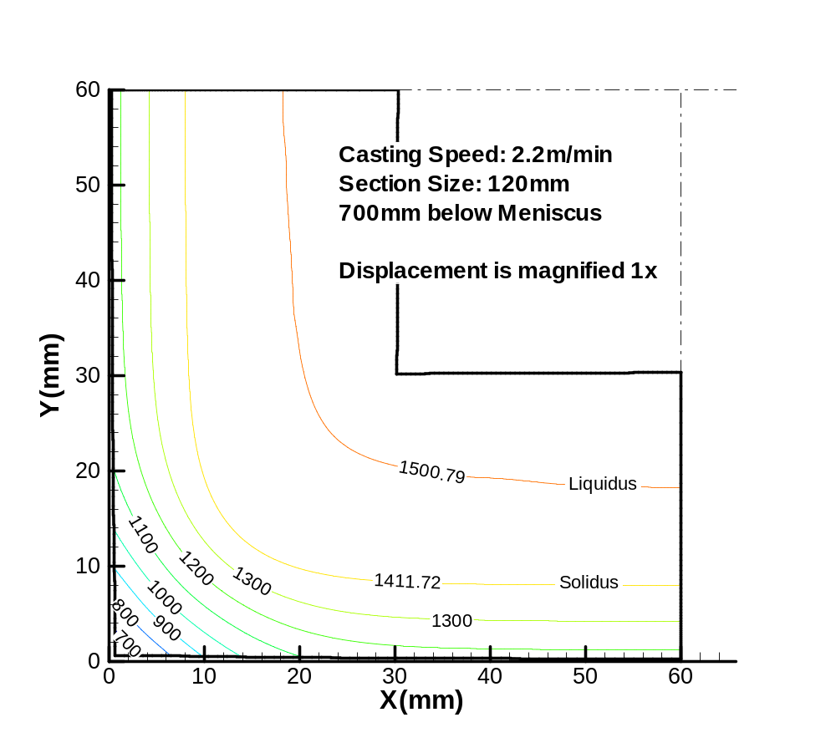
Fig. 33: Temperature Contours on Distorted Billet Cross Section Showing Cold Corner
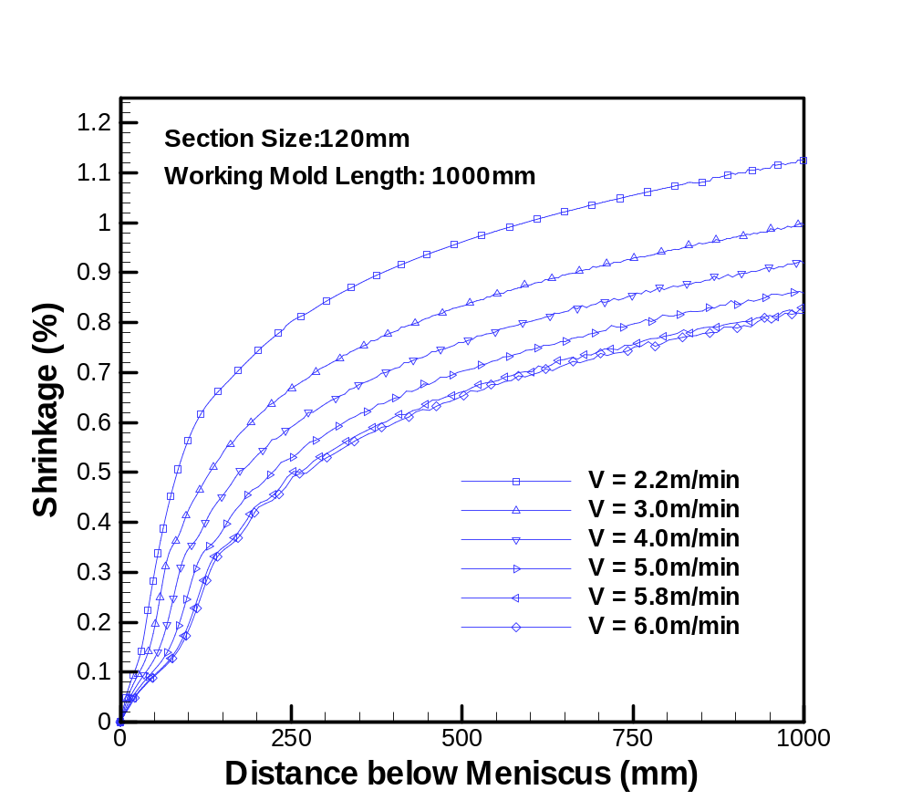
Fig. 34a): Effect of Casting Speed on Ideal Taper (120 mm Section)
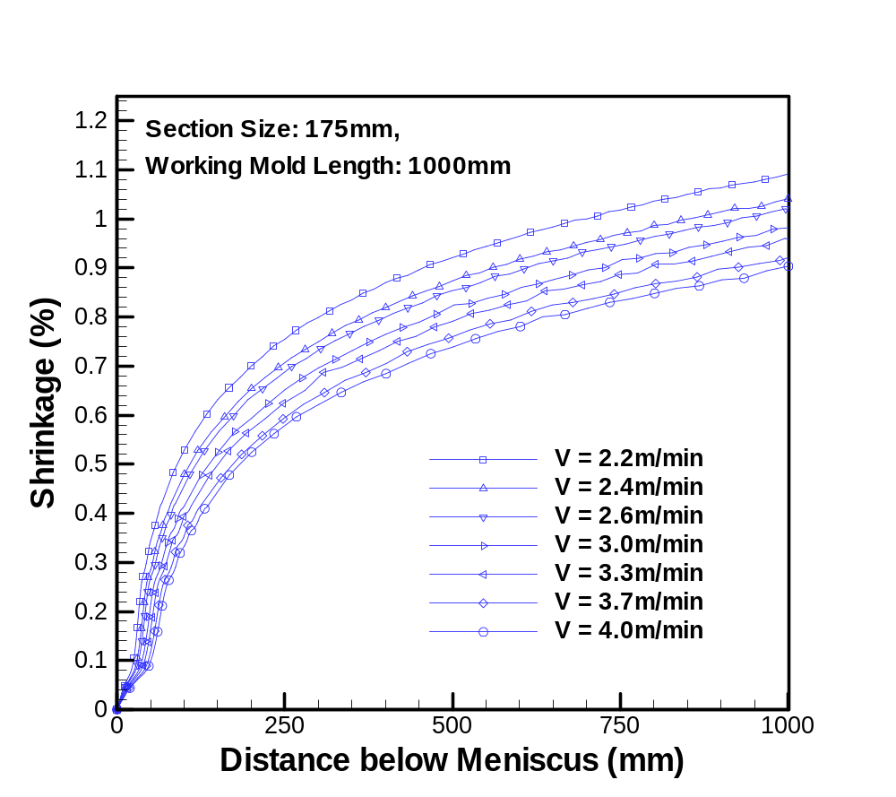
Fig. 35b): Effect of Casting Speed on Ideal Taper (175 mm Section)
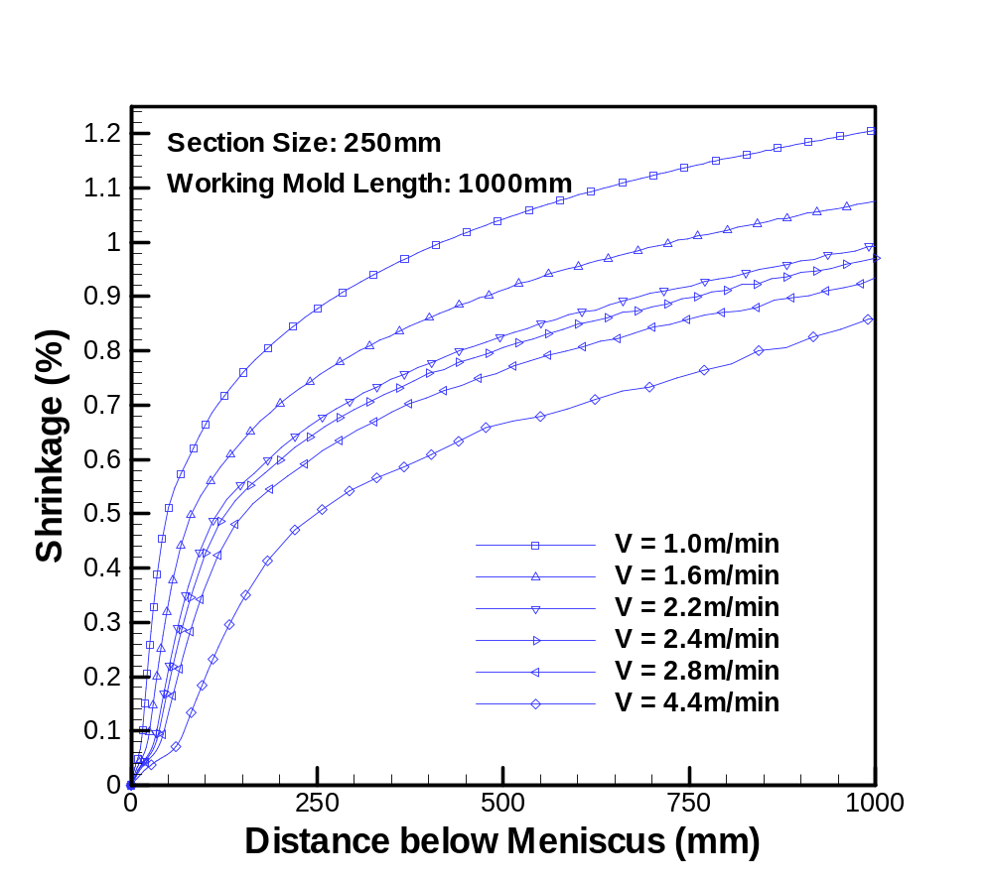
Fig. 36c): Effect of Casting Speed on Ideal Taper (250 mm Section)
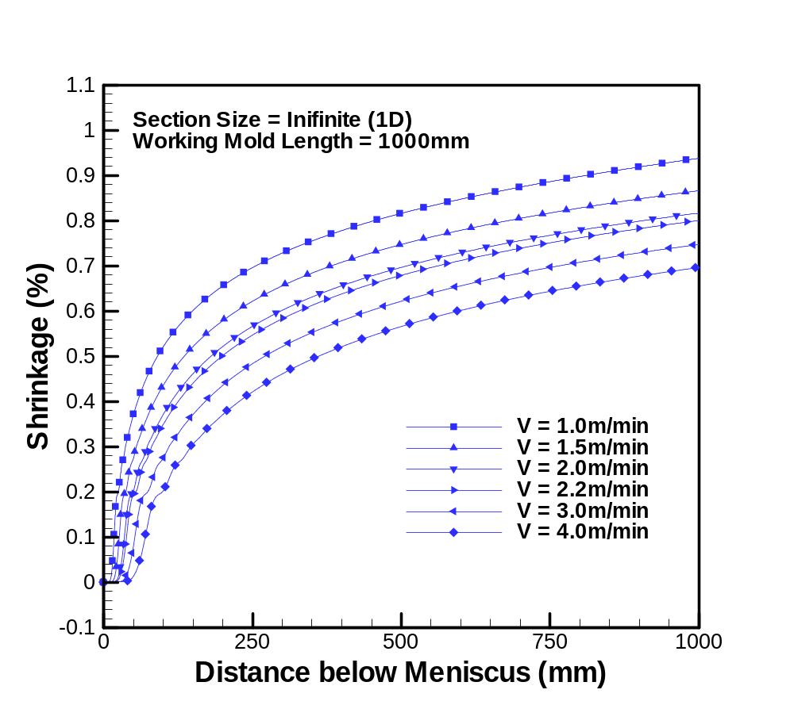
Fig. 37d): Effect of Casting Speed on Ideal Taper (1D Slice Model = Infinite Section)
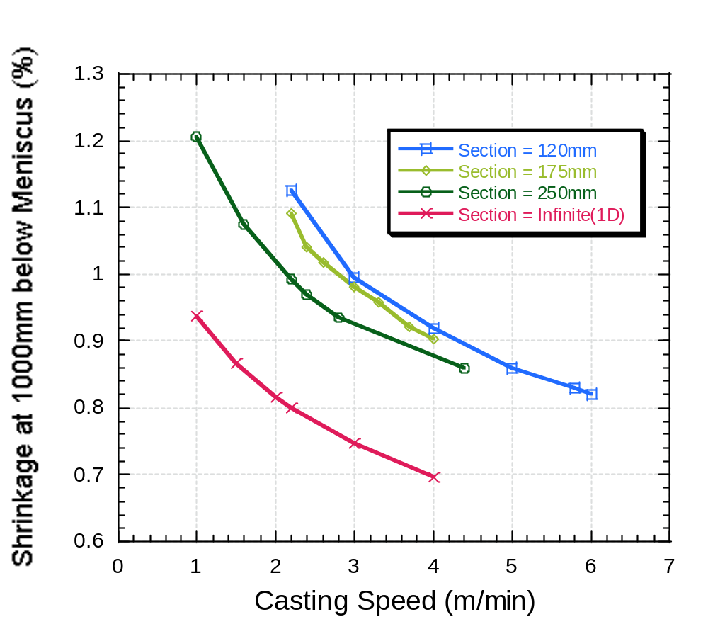
Fig. 38: Shrinkage at 1000mm below Meniscus for Different Conditions.
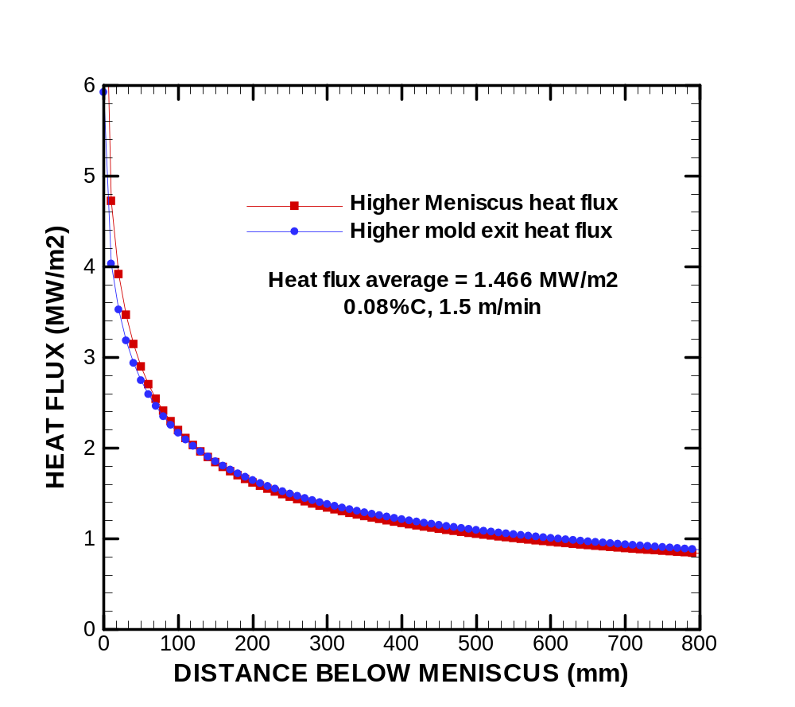
Fig. 39: Test heat flux curves with minor variation in curve shape
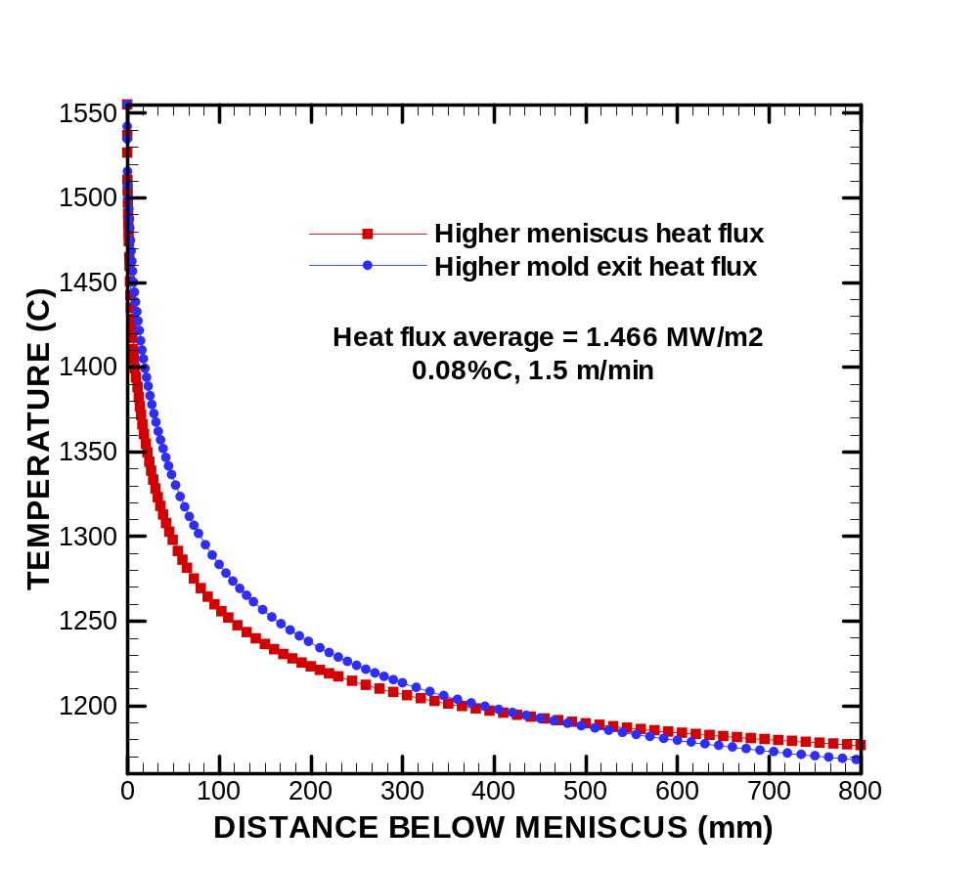
Fig. 40: Surface temperatures (slice domain) using heat flux curves in Fig. 41
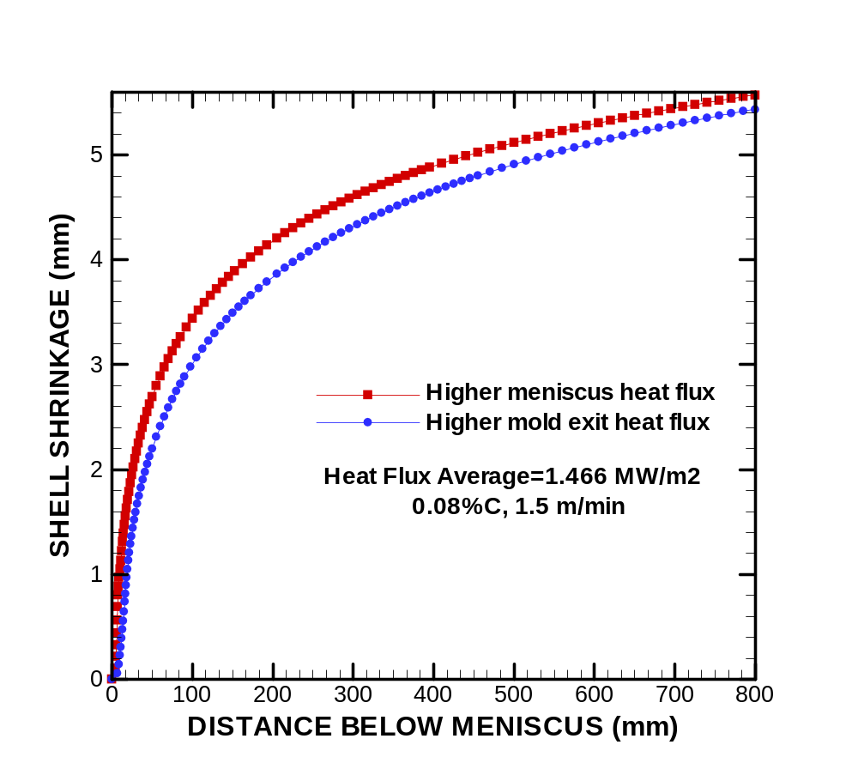
Fig. 42: Shrinkage predictions (slice domain) using heat flux curves in Fig. 43
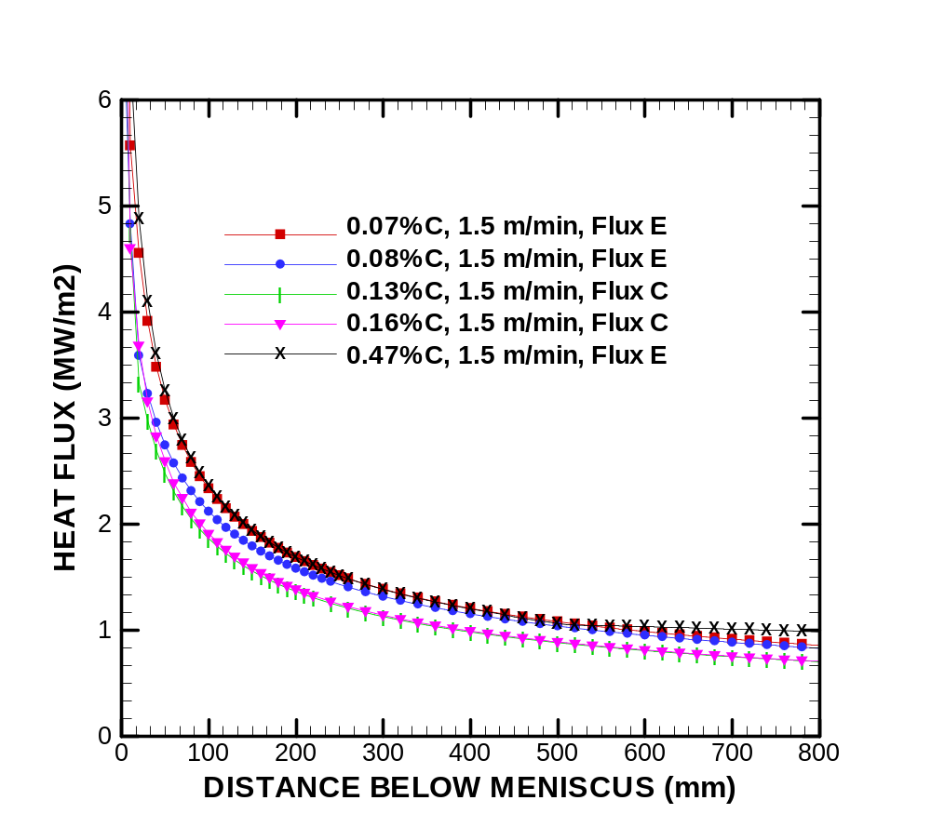
Fig. 44: Heat flux profiles for different steel grades (Table 9 conditions)
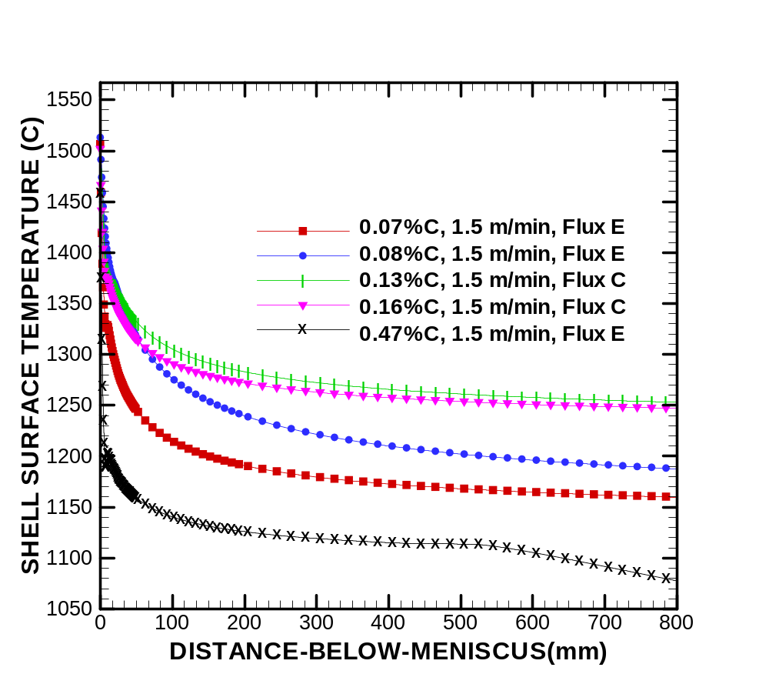
Fig. 45: Shell surface temperature for different steel grades (Table 10 and Fig. 46 conditions)
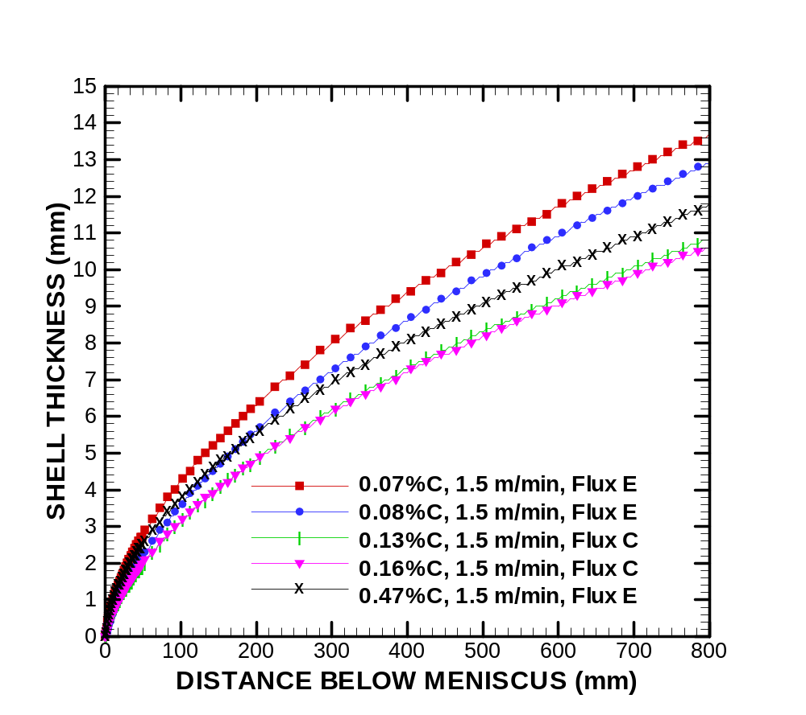
Fig. 47: Shell thickness for different steel grades (Table 11 and Fig. 48 conditions)
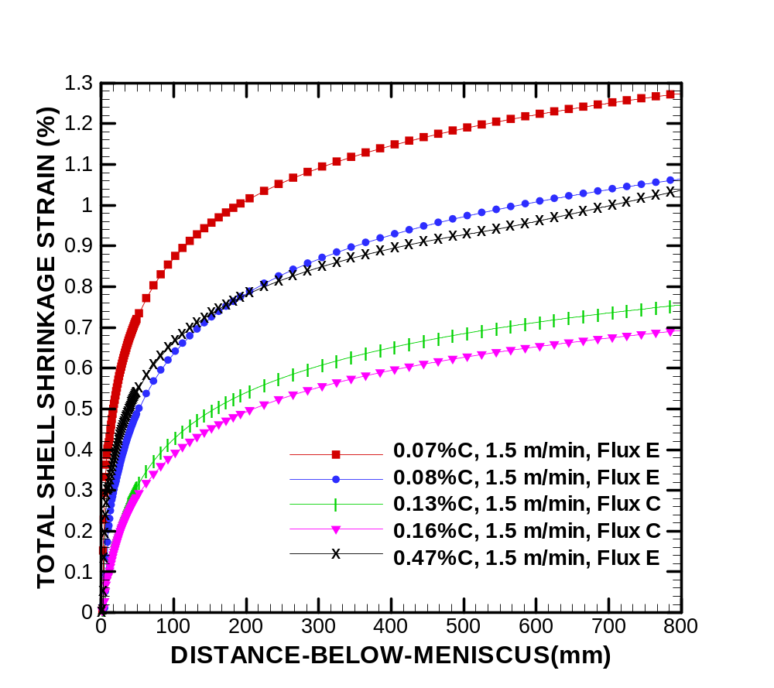
Fig. 49: Shell shrinkage (ideal taper) for different steel grades (Table 12 and Fig. 50 conditions)
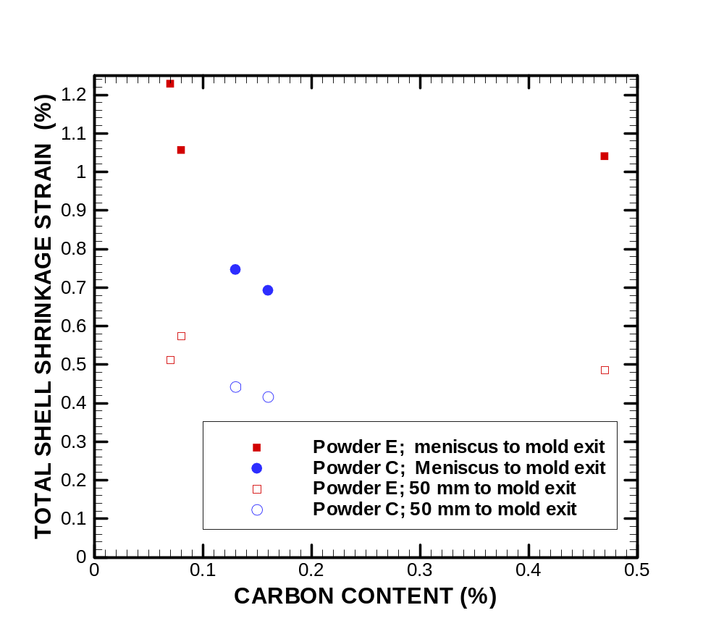
Fig. 51: Shell thickness at 800 mm below meniscus for different steel grades (Table 13 and Fig. 52 conditions)

